

**Physical Contact on Mount Shasta**

Report by Ricardo González

Mount Shasta, California, August 26, 2012

Abstract

Ricardo Gonzalez had an extraterrestrial contact experience on August 26, 2012 at Mt Shasta, California. Prior to the contact, a large group of approximately 55 individuals had a physical sighting of a vehicle that did not appear to be an aircraft or satellite. Ricardo’s 2012 physical contact occurred after the larger group completed the workshop on the morning of August 26. Ricardo got a psychographic (automatic writing) request to go back to the campsite and in total a group of 13 individuals once again had a sighting of what appeared to be an extraterrestrial vehicle. This was another “programed sighting” for a specific time (9:00 pm) that Ricardo had advised a few individuals previously so they could be prepared. Ricardo received another psychographic request to go deeper into the forest by himself. The vehicle projected a ray of light or plasma ball that transported him into a space vehicle for approximately 1.5 hrs. When he returned, it seemed that only 15 minutes had elapsed.

The Invitation for Contact

On January 22nd, 23rd and 24th of 2010, I participated in a national outing with the [contact] groups from Paraguay. The location selected was the Ybytiruzu mountain chain, which is located 18 km to the east of the city of Villarrica. During a meditation session that we held in front of the symbols on the stone wall of Ita Letra—a location that reminds me of the rock of Pusharo at Paititi— I received a message from the Guides inviting me to a physical contact. The experience, according to the brief communication, would take place on August 8 in the Chilca Desert.

Communication August 8, 2010 Chilca Desert, 9:10 PM. Antenna: Ricardo González

Oxalc with you:

We see that you have taken an important step. Every time you feel the messages that bring you together to tune-in with these times and places, a door opens and the universes are restored. Significant stages are coming to an end; the set of gears that has been set in motion is now arranging itself to lead to an exit toward the light, which is a path that you already know or perceive.

Let everything rise to the heights, conscious of the fact that the spirit of everything you have done strongly embraces you. Understand that the guidelines and events that we revealed to you sometime back are now coming to the fore. We have agreed to call this point the “re-dimensioning.” And this re-dimensioning begins within you before it is projected out into the whole.

We are watching you closely. And we want to remind you that we consider all of you brothers. We consider you part of our very existence. It is true that we can give you guidelines but we do not judge your errors or learning experiences. We know all that you can give and as such, we wait for you and will wait for you.

Trust in yourselves. Trust in us and flow.

Oxalc and the Guides on the mission

I was very excited and immediately shared the message with Francisco Camacho, a dear friend and long-time member of the contact group in Asuncion. To handle this message responsibly, we asked the (ET) Guides for a corroboration sighting. If the invitation were genuine, “they” would show themselves. And that is what they did: at the appointed time, a brilliant object appeared above the pyramidal hill; it was a sighting that we could all witness at the same time. This experience led me to take this invitation very seriously and I decided to prepare myself for August.

Soon after my trip to Paraguay, I contacted the long-time members of the groups—and moreover my very good friends—to set up the team with affinity and harmonious understanding that would accompany me to Chilca. The group was made up of Ruben Astacio (Dominican Republic), Isabel Cabral (Honduras), Nimer Obregon and Elard Pastor (Lima), Raymundo Collazo (USA), and Ricardo Zapata (Argentina).

**And this is how it all began.**

On August 8, 2010, when we were already in the Peruvian desert, we received communications and the Guides punctually appeared in sightings. But when the time for the experience arrived, I felt that I couldn’t go on...That I wasn’t ready…. How could this have happened to me knowing beforehand the importance of preparing myself?

I need to say that in February of this year I went through a very difficult personal situation —which has helped me grow a great deal—. I know that the Guides plan everything to the millimeter, but in 2010 I had yet to finish processing certain things. The Guides had always believed in me; this is why they upheld the invitation. Nevertheless, in the end my state of mind betrayed me and I couldn’t meet them in Chilca... The older brothers understood this and in a message they indicated that they would wait until I was ready….It was evident that they believed it was very important for the physical contact to take place.

After Chilca, I returned to the back and forth routine of trips and dissemination. I was focused on this until new messages arrived reminding me of the invitation to make contact and the need to be prepared. Mount Shasta, in August 2011, was one of the most important moments to verify if the “appointment” was still on.

On February 26, 2012, while I was in Tepoztlan, Mexico, the Guides sent me a psychographic message that referred to the trips in August and the invitation to physical contact. They were still monitoring everything… In the last lines they said: "We would like to reiterate the invitation for you to come with us again. If it weren’t important, we wouldn’t ask this of you. You are prepared" (Oxalc).

On July 18, the Guides once again referred to the invitation in a new message that I received in Buenos Aires: "In August, the conditions will be in place for you to go to the meeting that is pending. We repeat this. It will be at the foot of the dormant volcano" (Antarel).

At the foot of the dormant volcano? —I asked myself. In August everything would take shape.

On the trip to Sajama, I had an extraordinary demonstration of what the Guides were announcing. On the night of August 6, at the foot of the sacred mountain of the Bolivian Andes, beneath the lights of the ships that were stationed in the area and their fully illuminated structures, I felt a strange force take hold of me and I rose some 15 or 20 centimeters from the ground. Sol, my companion, witnessed this because she was very close to me.

That night, still shaken by what had occurred, Antarel explained the action in a psychographic message:

We gave you proof by lifting you from the ground. This is so you prepare, take responsibility for and become aware of the pending invitations; the conditions are in place for direct encounters with us in the month of August (Antarel).

After sharing this message, Luis Fernando Mostajo, my friend and brother from Bolivia, confided that during the sighting we witnessed on August 4 near the Illimani peak, he had received a mental invitation from the Guides to experience an encounter. It was strange given that when the intense light appeared at sunset on the Illimani —which, quite unfortunately, we were unable to photograph in the best way despite their long journey—several of us who were on the mountain at this moment had received different messages of a personal nature as if the older brothers were giving us directions.

We discussed this with the group that traveled to Sajama and I reminded the participants that the Guides, in their communication, had referred to a “window” moment, **a space in time between June 21 and September 21 that would be “propitious” for contact experiences**. It was an ideal framework to seal pending invitations. It was an invitation for everyone.

The message that I was referring to was the same that I had received in Buenos Aires on July 18—which alluded to contact that would take place “at the foot of the sleeping volcano”. One of the paragraphs of this communication said the following (textual reference):

You must know that during the period from the solstice in June to the equinox in September, a “window” moment was opened and it creates the best conditions for contact experiences with us and with the White Brotherhood. It was thus estimated by us. As such, be prepared. (Antarel)

The coordinate for the contact finished taking shape on August 7 after I photographed a ship coming toward Sajama. Ruben Astacio also documented this with his camera just moments later. Immediately, we began the connection work that allowed us to receive a psychographic message that I included, but not in its full form, in the report on our trip to Sajama. We did it like this because we wanted to handle the Guides’ invitation discreetly.

In the message which I psychographed, indicated that I could experience the encounter on Mount Shasta, where I had already scheduled an outing-workshop for August 24-26 [2012]. The curious thing is that at this moment I felt that Luis Fernando could firm up his invitation for the same dates at the location where he received his message: lllimani.

I need to emphasize that the communication that I received in Sajama announced that the Guides would be present on August 8 at 7:00 pm, at the foot of the volcano. This happened just as it had been described and was evident to the entire group. If all of this was so important—without a doubt— we had to work as a team to see if, through a group effort, we could achieve direct contact on these dates.

Today, while writing this text, I recall with great joy that we achieved this thanks to everyone’s support.

Although it is true that I did not publicly announce the invitation to contact that the Guides had extended—to avoid generating excessive expectations that could affect the experience at an energy level— I must say that that I spoke privately with different groups in various countries such as Spain, the United States, Mexico, El Salvador, Honduras and the Dominican Republic, Argentina, Peru, Chile Paraguay, Bolivia and a few others so that they could provide support at a distance. Time has taught us that when we are all focused on the same purpose, the contacts that have been scheduled flow with the intensity that has been scheduled. For this reason, support was highly important.

Mount Shasta

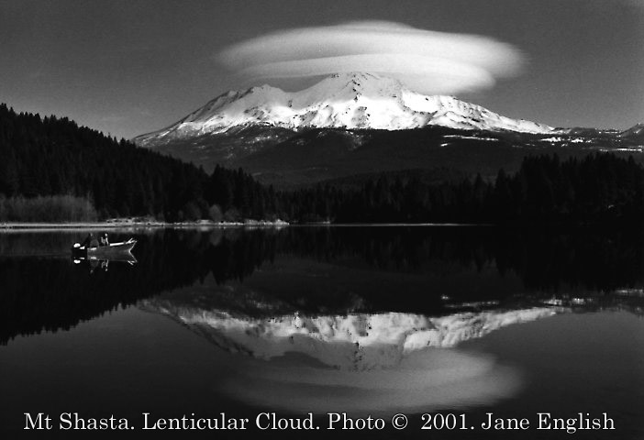Sajama is a dormant volcano. But so is [Mount] Shasta. Maybe the Guides were referring to the mythical mountain in northern California from the beginning. Undoubtedly, it is curious that it was on Shasta, more than 10 years ago, where I received confirmation for the physical contact in 2001. This experience allowed me, for the first time and in a complete state of consciousness, to go inside a ship and accompany the Guides on a journey to their orbital bases (Celea Report).

Shasta is a magic mountain that captivates you. It is famous throughout the world for the story that links it with the intra-earth base that was more than likely built by the survivors of Mu (in the Pacific Ocean although some writers confuse it with Lemuria in the Indian Ocean). In the new age circle of California, the mysterious internal city is known as “Telos.” This name is the most frequently used to refer to the subterranean center. The primary disseminator of Telos was the Canadian channeler Aurelia Loise Jones, who claimed to have established contact with the "Council of Light of the 12 Ascended Teachers" that operates in the fifth dimension below the Shasta massif.

Beyond the controversial channelings that speak of the lives and customs of the supposed inhabitants of Telos —some of which, in my opinion, have given an overly “religious” connotation to the mountain— two things are certain. Mount Shasta is a very special place and a subterranean/inter-dimensional base does exist there.

At the foot of the magic mountain, we gathered 55 people from different countries, the majority of whom were residents in the United States and Mexico. Although the idea was to conduct an encounter-workshop, many of the people who were present were part of contact groups. This allowed us to sync with the location very quickly.

From the moment that I arrived on Shasta, which was the night of Friday the 24th, the Guides began to show themselves. The first thing that I did right after I got out of my friend Raul Dominguez’s truck (Raul is the group coordinator from San Francisco) was to move towards the center of the ground level that we had chosen to set up camp, which was a place known as "Sand Flat.” Sol came with me.

At this moment I tried to contact the Guides. I just wanted to know that they were there.... Then a bright object appeared in the sky. It was orange-colored and lit up. Then it disappeared in the middle of this clear night with a crescent moon (with 70% luminosity). We asked if they would show themselves again and at that very moment, a fast-moving, low-flying probe (canepla) appeared almost scraping against the tops of the pine trees. It was extraordinary.

When we returned with the group, Carlos Federico of Mexico and Mary Fajardo of Colombia alerted me to the fact that some strange “flashes” of energy were appearing in the sky. I was also able to see these bright lights —which were similar to those we had seen in Chilca. After this I felt that a ship was parked above our heads, which is the same thing that happened to me at the Sajama mountain. Without giving it much thought, I took out my digital camera, which has an optical zoom of 42x, and was able to capture the pulsing light that was in movement and which varied from white to blue. I took various photographs being sure to hold holding the camera steady. In the images, one can see how the object moves as if it were drawing “symbols.” The stars in the sky appear to be fixed as a reference for its movement. And this is how the mountain received us...

Later on, “they” appeared once again and on this occasion, we interacted with one of their ships, which was very high up on the meridian. The ship lit up more intensely each time we pointed our halogen lamp in that direction. I knew that despite my preference, not all of those present (more than 50 people) could be told of the invitation. I found this difficult given that many people who were close to me were very prepared and I would have liked for them to witness our older brothers’ approach. However, I needed to be responsible and not risk this new opportunity to experience a meeting with the Guides.

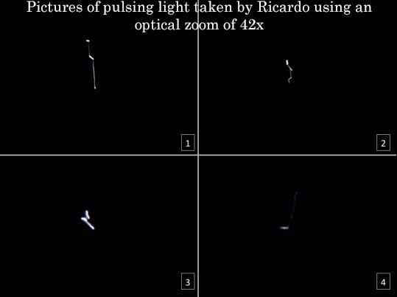

As such, I included only Raul Dominguez and his wife Lorena, both from San Francisco; Alma Reyes, Suyapa and Luis Ochoa, from Napa Valley; Mary Fajardo and Carlos Federico, who belong to the South San Francisco group. Sol and I completed the group, which later on –due to life’s own “synchronicities”- would include four other people.

We experienced very special moments of meditation, sharing and feeling on August 25th and 26th (until mid-day, when our outing ended). As I have already said: Shasta is captivating. I love its pine forests and the silhouette of its silent mountain, which rises above these large trees like a supernatural guardian.

As is always the case on our camping trips, some had personal experiences in these woods that speak and teach—as was the case of Carlos Federico and Raul Dominguez. The woods help you travel down the path of truth, as if it were a powerful shaman. Many experienced luminous phenomena during their walks as well as orbs, sightings and energy of all types.

On the night of the 25th in Shasta, I received a mental message from **Antarel** which was accompanied by a sighting. My old extraterrestrial friend confirmed to me that **on Sunday the 26th, at 9 pm, they would show themselves and after, I would meet up with them**. Without further delay, I shared this information with the group that was aware of the invitation. We had to be focused on what was to come.

On the 26th at mid-day, we ended our group outing with a connection work between Sajama and Shasta, something that Luis Fernando and I had already received in Tomarapi, and which Carlos Federico confirmed on the mountain. It was impressive that during this effort, an intense wind appeared and created swirls in the air, just as had occurred in Sajama…. Many of us felt that the “wind” of Shasta was driven by something “invisible.” This also happened to those of us who had traveled to the Gobi in 2007….It was not a normal wind….

It was at this moment that Francisco Huerta, who is from Mexico (he has lived in California for many years and is a member of the contact groups), pointed out that a large cloud had been hovering over the mountain since that morning, which had also been the case in Sajama on August 8…. The strange thing was that this cloud was only present for a few hours —it was the only cloud in the clear, blue sky— and disappeared later without a trace. There was no water vapor or ash on the dormant volcano. Shasta is famous around the world for this phenomenon, which seems to indicate that the place is home to some kind of energy activity. Those who study Shasta say that the mountain holds the world record for forming “lenticular clouds.”

After this we picked up camp and climbed the mountain on the route that winds around the viewpoint, which was only 10 minutes by car. The landscape that is visible from this spot is extraordinary. We had a new sighting there, in broad daylight. It was short but convincing to the point that it brought to mind the old films made by Billy Meier in Switzerland. Sol, Aleyda Galeano (Colombia) and George Melendez (El Salvador) and I saw some kind of flattened, round, white disk, which reflected the Sun. We were so excited that we tried to film and photograph it. But it was impossible…… It didn’t show up in the camera! We could see it but it literally did not show up on the camera. Despite this I kept filming and the only thing that I could see on the video was the beautiful sky we had seen that day….it was as if the object had made itself invisible to our technology but had nonetheless allowed us to see it for a few fleeting moments. I felt that they had done this as a “demonstration….” The disc “vanished” like nothing into the sky. At that time, I knew that contact would definitely be made...

Inside the ship and meeting with Antarel again

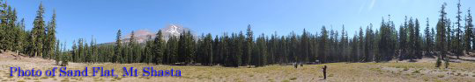

We returned to Sand Flat at 7:00 pm. The place had changed. It seemed as if it were charged with a penetrating energy. I felt that this was the fruit of the group’s labor during several days of meditation but I also felt that the mountain had “lit up.” At that place, we met up with Francisco Huerta, Alberto Arreola (both from Mexico), Maria Pascuala (El Salvador) and Emilio Salazar (Mexico). They had felt they should stay despite the fact that they were unaware of my invitation, although "Pascuala" - as we affectionately call her - later confided that she “knew” that contact would be made that night, which is the reason why she wanted to spend some more time in Shasta. So the group ended up having 13 people.

At this time I reminded them about what might happen: that at 9:00 pm I had a [scheduled] meeting with the Guides for a physical contact. We needed to be united and control our nerves in the face of any manifestation. And we were alone in the middle of the mountain. The presence one could feel there was impressive…. Everything was different.

We agreed to use mantras to work on our meditation and *energy elevation practices* from 8:00 p.m. on. Of course, the contact would occur regardless of whether we did these things, given that we were dealing with an experience that had been scheduled by the Guides. But over the years we had learned that it is important to maintain a state of connection to handle large commitments, particularly if we are a heterogeneous group of people which should be in tune and vibrate as high as possible. We achieved it without difficulty: the group was very united, focused and calm. Raul Dominguez led the preparation work. And in the middle of this process I received the following psychographic message:

Yes, we are close. You have done important work on the mountain. You have inter-connected with the energy network that ties together the centers of power (in reference to Sajama and Shasta). Brother, we will get closer. All be attentive to our signs: It will be between 9:00 and 9:30 pm and with the sign you will go to the location in the clearing that we told you about before.

We are here. It depends on you.

With love,

Antarel

After the message, I closed the notebook and continued working with the group. I looked at my watch: it was 8:50 pm. In 10 minutes everything would begin…..

I felt very emotional about it, just as I was in Chilca 11 years ago. I perceived that Antarel and the Guides were close by. I “visualized” them approaching. I was filled with indescribable emotion at the thought of seeing them again. But I have to say that I was also nervous. Everything was very intense and many memories of past experiences embraced me in that instant. It was as if I were living everything all over again. I tried to calm down and I think that I was largely successful. A sensation of security and decidedness took hold of me at that moment.

So I looked at my watch: it was 8:59 pm. I didn’t take my eyes off of it…. I asked myself, would they be punctual this time around? Everyone in the group knew about the appointment time. I had already told them. And what if they didn’t appear? How would all of this affect the group? And me? In the message they had told me that they were here and that everything depended on me… I said to myself: “Ricardo, do you want to go through this, and all that it implies, once again? Are you really sure?”

This minute left seemed like an eternity, just like other moments I have lived in this contact experience… But I decided that yes, I wanted to do this…... And just as the clock struck 9:00 pm, I got up slowly, and directed my eyes to the sky….and they were there... In a clear sky with a bright moon that only let a few stars shine through —it seemed like the light of “day”. The moonlight cast our shadows on the floor, and a beautiful bright object, which was large and bore an intense yellow-orange color, appeared flying low and moving slowly in silence as if it were circling the area where our group was. It was a solid sighting.

I alerted the group to the presence of the ship. And looking at the object, my companions said very excitedly: It’s 9:00 pm! As they checked their watches in the midst of the hubbub. It was the sign from the Guides. They had done everything just as they said they would. .Without thinking about it much, I got up and said goodbye to the group to go to the clearing in the woods.

The group was initially so excited about the apparition that they all stood up and tried to film, however unsuccessfully, the ship over Sand Flat. Despite the clarity of the sighting, no one was able to capture a photo of the object, which is exactly what happened to us when we went to the lookout point on the mountain. Then, Suyapa Ochoa, who is from Napa Valley, suggested resuming support work while I made my way to the contact. The group resumed its efforts with such a force that I could feel it during my walk.

As I came close to the point of contact, which the Guides had previously revealed in a personal experience, I could hear the group’s chants at a distance and also perceived the support of many friends who were aware of this invitation. I didn’t feel alone for a second. But, despite this, when I arrived at the point designated for the experience and when I “breathed” the resounding presence of the Guides in the woods, I became a bit nervous. Although I had already seen them during other physical encounters, the energy that they mobilize is overwhelming. Additionally, the fact that I knew that I would step onboard the interior of one of their ships filled me again with indescribable sensations. I asked myself why it wasn’t taking place through a “xendra” [a dimensional portal].

A second luminous ship appeared in the sky over the woods where I was standing. It flew over me and seemed to move in the group’s direction. But something broke my concentration. Something that I hadn’t expected: I heard children playing nearby; they seemed to be laughing…. I thought: “This can’t be, there are people camping here...”

The voices came from the clearing where I was heading…Disconcerted, I continued to approach the spot… And I found a group of 5 or 6 children, including a little blond girl. All of them were very young children and they were playing and running around in the area. They were around 7 years old and seemed to be American children. At that point I forgot about the contact and thought: “Where are their parents?” What was happening?

I felt hypnotized as I walked toward them. They didn’t seem to be bothered that I was there. And then they came running toward me and joined hands to make a circle around me. It seemed “real” but just as they began to rotate around me —as I looked on with surprise— an intense flash, like a very brilliant white, appeared on all sides and I was forced to shut my eyes as a powerful force “pulled me up,” at dizzying speed, to the sky above….just as I had experienced in Chilca in 2001.

All of a sudden I was standing in a large circular room. I had to wait a bit to fully view the room because I could still see the “flash” of light in my eyes. I could only see that it was circular in shape and I perceived that an intense silence filled the room. And in front of me, I could see the silhouettes of two people….

In spite of it all I was more or less calm and was trying to soak in the situation. As my eyes became used to the room and I could see that it was about 25 meters (83 feet) in diameter and there was a large oval door that was “open” in the circular wall. And **Anitac** and **Antarel** were standing at both sides of the door. Anitac was standing to my left smiling. She was holding a black metallic cube—which reminded me of a similar object that I had seen in the contact in Chilca!

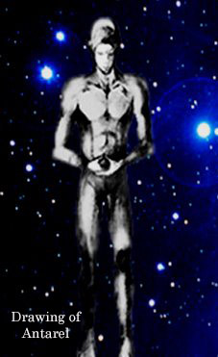The extraterrestrial Guide was dressed in a silver jumpsuit but her hands and face were uncovered. She is a woman and appears to be around 40. She has very light blonde hair and an “average height”— I would say a bit more than 1.70m (5’ 6”). This was not Antarel’s case... The giant extraterrestrial, who was to my right and closer to me, was around 2.70 m (8’ 8”). His skin was very white and his build was athletic. Their bodies are quite “perfect.” But this is not due to any special training. They are like this for genetic reasons. And they are like a “perfected” vision of a human being but more stylized. Antarel was also dressed in a metallic jumpsuit that was similar to Anitac’s. His hair was white and so long, straight and shiny that it seemed “artificial.” it was perfect and clean. His honey-colored eyes, which were as human as ours, irradiated something familiar to me. Something that made me feel as part of them.

Welcome once again - he said to me telepathically as he smiled . “You did that thing with the children.” I told them. “Remember that we are mental doctors” replied Antarel; “we can generate very real holograms for you. We did it so you would relax before coming up.” “And how do I know that I am not in another hologram?” I answered, although I “knew” that I was there with them. Antarel smiled tenderly and approached me, which made my entire body shake….He brought his left hand to my chest and touched it hard with his giant index and middle fingers while looking into my eyes said in perfect Spanish:

"Ri.cardo. We are always with you... I am your friend, your brother..."

I don’t know how to describe this….It was one of the most intense moments of the experience. Never before had I heard the Guides “speak.” I knew that they could learn our languages but they had always used telepathic communication in the encounters. Speaking in my language, and calling by my “human” name while touching my chest....is one of the most marvelous gifts I have ever received…

“You are here physically,” he continued speaking, but now mentally, while he gently removed his fingers from my chest. “It was important that the experience take place like this. We connected with you when you were a child. And we guided you to the groups when you were just a boy. Now you are a man and we are still with you... This has been the process for many of you.”

What Antarel was saying was true.. And it was amazing to see that the extraterrestrial continued to look like a young man of about 35—in truth, they can live hundreds of our years— that I met so many years ago in Chilca. Now I looked older than he...

“Our time on Earth is but an ‘instant’, brother”—said the Guide. “We have another perception of time and life. Because of this we understand your doubts, questions and demands. We would like to explain to you all many things but everything needs to be meted out at the right time so that you can assimilate the information the best way possible.”

“Why go up in one of your ships again? Couldn’t it have been done some other way? Perhaps through the doors that you can open?” I asked these questions out loud because I felt more comfortable because the Guide had spoken to me in Spanish. Now it wasn’t anymore a conversation between a witness and an “extraterrestrial” that I had seen before. Antarel had put me at ease and created an atmosphere of trust and naturalness despite just how extraordinary it was for me to be there.

“You had to be here physically,” he assured me.

“So then the xendras are not “physical?” I expressed this question mentally, entering into the usual telepathic contact style.

“We know that you have been reflecting about it: there are different doors, folds and experiences and all of them occur at different levels according to what we schedule and also in line with your preparation. But even in the case of some dimensional doors that can be used to physically transport either you or us if we pass through them, the energy in motion is more subtle and connects with other types of forces. In other words, it is a parallel, holographic reality. Because of it, in the midst of these experiences you appear luminous and you perceive things differently even if you are “physically” there.”

“I understand…”

“The xendras were established from a contact perspective as the main tool for close encounters with you,” he said. “It is a less traumatic way for you to have a meeting with us and at the same time gives us a means to teach you about other inter-dimensional realities that will have a foothold on Earth in the near future. The physical contacts which involve a closer relation with us are individual. On a few occasions, we attempted encounters with groups but found them largely unsuccessful.”

“Why do these experiences have to be individual? Why do you find group encounters so hard to handle?” [I said]

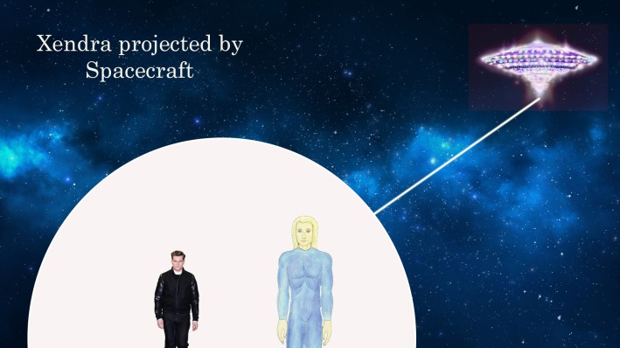

“This is stipulated in our protocol for non-direct intervention. Our code of ethics with you, which implies a deep respect for your learning and process on Earth, does not allow us to have an impact on groups of humans in collective physical encounters **if the participants are not completely “aligned.”** This means that it does not depend solely on us and our contact behavior; it also depends upon your preparation. Physical group experiences are in our agenda but not at this time. In inter-dimensional experiences, by not being totally involved in the physical plane in which human beings base their perceptions, we find it easier to connect with various witnesses. We don’t affect their day-to-day lives. The xendras have an adaptation mechanism in your brains that is similar to the dream dynamic. That is why they can be assimilated better after all. According to the content of what we want to transmit, it is the “vehicle” of transmission or scheduled experience.”

“Is this why the contact had to take place here and in this way?” [I asked]

“If we had taken you to Celea or inside the Cave of the Tayos in a xendra, it would have been different. It is true that the message will be the most important matter- the content of the experience and not the phenomenon that surrounds it. But some things arrive in a different manner when contact is lived in each of its stages. Given your work within the contact program, it was necessary for you to live things materially. We also calculated that you could handle all of this mentally.”

I asked the Guide: “What is my job in all of this?” Even though I felt I knew the answer.

He answered slowly: “You know it; your job from the beginning has been to activate the information, then to organize and disseminate it.

I said: “But the information in and of itself is not important. It’s just knowledge.”

“That’s right,” said Antarel. **The important thing is what you can do with the knowledge** **and not simply remaining with the data you have gathered**. Knowledge of the true history of the planet, your origin and the process that you have undertaken as a species ensures the conscious passage toward the Real Time of the Universe. A new reality awaits you where everything will be different. But you must understand it to assume your forgotten role as engineers of creation. You are expected to “wake up” now and to “build” in that new time.

“I have some questions about it,” I said.

“We know,” said Antarel, with a very human smile.

I asked: “According to the messages that we received from you, which speak of a ‘gradual’ entry into this other reality, is it really like this? Won’t the change be sudden?”

“The Real Time of the Universe is a ‘concept’ that we transmitted to you so that you could understand the multi-dimensionality in which we move,’ said Antarel. “There are different ‘realities’ in Creation that would be impossible to explain to you. But the important thing is that you will integrate into one of these “states,” which will affect the cosmic weave that preceded the installation of an alternative time on Earth and the subsequent appearance of human beings. The time that you have been moving in, although it is ‘artificial,’ was established in accordance to higher laws. Everything in the Universe is order and symmetry. Nothing can be done if it is not supported by the large network……

“In a long process that we have monitored, you have gradually abandoned that artificial time to connect to what we call the Real Time of the Universe on the path to a peak moment that will occur during the solstice of **December 21st** of this year. The importance of this date is that it **marks the** **point of “no return,”** ensuring the path toward what we have always been waiting for: **your integration with a cosmic community**. In other words, December 21st marks a special moment but does not constitute your definitive access to us. Instead, you will begin ‘*entering*’ in us. You will begin to meld and to really know the Universe. Your scientists will see things that they have never seen before. They will have to correct old theories about the Cosmos. With time, they will truly discover what the space in which they live really is……

“I believe that our scientists already perceive everything that you say.” [I said]

“But they haven’t said everything. And they still haven’t foreseen what will come,” assured the Guide.

“What is coming,” I asked?

“The “re-dimensioning,” the connection…. Our scientists will detect unknown, inter-dimensional and energy phenomenon that will cause you to rethink everything. The Earth will once again be the “mother” of all things.” And your gradual integration with this membrane of reality where we flow will allow you to “create” new possibilities in our worlds of origin and even in us as creatures. You will open the door. You will lay the path. Although this is still impossible for many of you given the injustices that are evident on Earth. But as we have said before, there is more light in you than you can imagine. You can do marvelous things. You are just asleep…..This is why you need to remember….The final moment of everything will be to remember….”

“So you are confirming that the passage of the Earth and the awakening of many people are on the right track?” [I asked]

“Not only is it on track. It is done,” said Antarel.

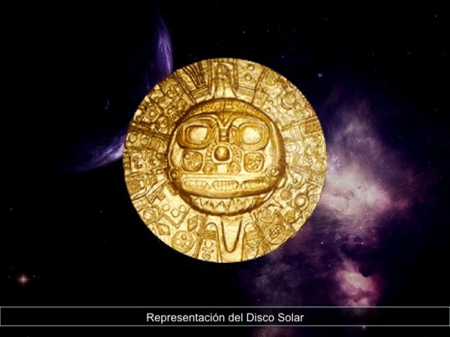 “These past 10 years we have been working with the solar discs,” I continued with my questions. “In your messages, you also confirmed that the activation had been definitive. What comes after this?”

“It has been important to connect with the discs and with the centers of power where they are located,” Antarel replied firmly. The tools are “beating” and their energy will accompany the Earth for a long time. The preliminary stage of the activation effort ended definitively in August.”

“But Antarel,” I interrupted the Guide. “Why were there so many contradictions regarding the information about the discs? I have no doubt that they were transmitted to us but different visions are circulating about what you revealed to me in Celea.”

“Nordac,” - said my giant friend now calling me by my cosmic name - “access to a true information of relevance goes through different stages that involve questioning, confusion, verification, understanding and finally profound validation. The locations of the discs that we transmitted to you are correct and your group work in this regard has been extraordinary. But just as we have indicated in these messages, there are other mirrors that are synchronized with the network that we revealed to you.

At that point, I remember our outing with the large group prior to Shasta where we all meditated with the “13 Names” or the Mantra of the Solar Discs.

“The most important thing that you have done with the discs,” said Antarel, “has been to receive their key tonal keys and to transmit them to the brothers. Thousands of people are singing this vibration, which maintains the discs that have already been activated awake. And, furthermore, this will connect you in harmony with the sanctuaries of the White Brotherhood. The sound of the discs opens the doors for contact. Even for us.”

“I understand,” I answered the Guide reflectively. But now you may have seen that many times I’ve been overcome by the contradictions. If different people in the world are being connected, why is the “language” perceived different in each rapprochement you make?”

“We have only one message, replied Antarel firmly. It’s the witnesses who interfere and contaminate what we transmit. We are conscious of this and this is a risk we assume given that with time, we expect them to improve as channels and “means” for our communications. As such, in some of the messages we are perceived as more “mystical” or more “scientific.” Sometimes this happens because it is the way with which you decode the experiences. With regards to us, in reality, we don’t have what you call a “personality.” It is true that each of us has a “characteristic" that distinguishes our subtle bodies and life experiences; that we are learning things from you and that at times you may feel us as being very “human” but we are beyond the mirages of the mind.

“So how can we avoid these interferences? What do you suggest?”

“You need to have a better understanding of how our mind works,” said the Guide. “You have already received enough instructions to train about this. It is also necessary for you to cultivate discernment and to continue to learn.“

“Do we need to learn more? To investigate? I have also thought this was the case… But one could think that this might lead to a subconscious contamination of the messages.”

“Not if you begin to work with your mind,” assured Antarel. “Learning expands your brain’s capacity to put a chain of information into perspective. This allows us to speak of other things.”

“And love? How is love part of this?” [I asked]

“Remember what you have learned: **the human being is pure by nature**. And your actions harmonize you with love, the most powerful force in creation. Your test, as such, is not in the soul, which is a perfect manifestation of love…it is in your mind, which can be a great obstacle or a great ally depending on how it is trained. “

“I have more questions Antarel.” I was standing in front of the Guide, trying to dispel all possible doubts. “And the Rock of Chintamani or the "Genesis Rock” as you call it, will it return to the Universe soon? In Sajama we are also told that all 32 would go, what does this mean? What will happen on September 21? What will come after?”

“The main reason of this encounter is to answer all of these questions,” said Antarel. “But we won’t be doing this….You have been brought here at another’s request.”

So Antarel took a few steps back and I saw Anitac close her eyes as she put the black metallic cube to her chest, holding it in his right hand while placing her left hand over it. The cube became “transparent” and a “distortion” appeared before me and captured my full attention: some kind of bubble, like water, was “inflating” in the room until it was, by my estimation, a bit more than 1 meter (3.3 feet) in diameter.

I saw very clear images through that sort of “plasma window” which allowed me to faintly make out Antarel’s silhouette through it. I could recognize a mountain which I had never visited but with which I was familiar due to an experience in the Gobi desert. It was the Belukha...

Later I saw a kind of “hangar,” whose lateral walls were dotted with crystal urns and in the middle, at the end, there was a large chair made of rock. This was the same enclosure that I had seen in the Gobi after a projection to the ship of the 32 extraterrestrial teachers that founded the White Brotherhood.

The next image was a face that began to take shape. It was the face of an old, imposing man with Nordic features and thin white hair. I had seen this before during the same experience in the Gobi. Only this time, his eyes were open and I could see that he had beautiful blue eyes…..

“Emuriel...” I said, trembling.

“The times that we have announced to you are very near,” he said slowly. I was listening to his powerful voice mentally in my head. “Our transformation is imminent and with it our desires are fulfilled.”

“You are... going to return...just as the messages said...,” I said. I was trembling and felt dwarfed by the situation.

“We aren’t leaving in the literal sense with which you understand a departure. We have responsibility to the White Brotherhood of Earth and to you. We will be following everything closely from other planes but will not be residing in your world. This will occur on September 21...

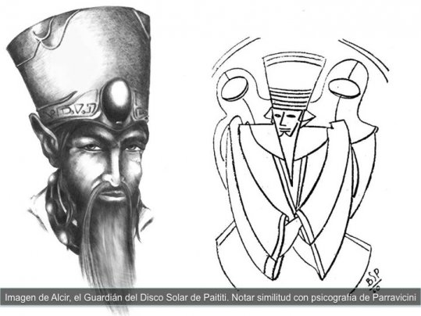 “Yes, and it has been possible thanks to everything that human beings have done by planting the seeds of hope despite the tests and proving that we were right about your potentials. Our cycle is complete and yours begins…..”

I then saw the crystal of the Sajama —which used to be located in the Gobi—, the "Rock of Genesis" or the "Rock of Chintamani,” which was projecting an intense and beautiful white-blue light...

“The Rock, the “Oracle,” which is beginning to be “read” by humanity to write the story of your future and ours; it has begun to mutate, to find its meaning and mission. This is why you see the color blue traveling: it is the energy of your world’s aura. It is your energy. Also, the energy of where it came from. This experience joins our past and the future which you represent. It is also a portal. Understand what we are showing to you and share it with your brothers.”

“The rock, when will it come back?” [I asked]

“Some time will pass but its return is guaranteed. **It will carry the human experience, the Earth’s energy, toward the Origin Universe, affecting the matrix, the source**.

“So,” I asked, “is this crystal the one that will end up “affecting” creation?”

“You, as living beings on this planet, are affecting the Universe with your feelings, thoughts, and actions. And everything you do upon connecting with the Real Time will be more influential for us, for everything….. The crystal gathers this information. It is a registry. And it has been part of the things that have been scheduled from the very beginning.

“On September 21 - said Emuriel - the beloved Master who also taught us the way will manifest, glorifying our bodies and the ship where we are located. We will be transformed when its presence is light in the midst of us. So we will awake and we will have fulfilled our duty on Earth...

“Jesus... They are speaking of Jesus... I knew it…” I said excitedly. “But how will this happen? How will this manifestation come about?”

“It is not the definitive return that He announced to you,” Emuriel clarified. “On this date a fold will open that will allow two realities to overlap, which will unite us to his presence and facilitate his luminous visit in the place where we rest. It is this way because He is the spiritual head of the White Brotherhood of your world. The Lord of Love, Truth and Time.

“At this moment, which will occur when the first stars light the south of the world, you will be able to feel his presence if you open your hearts. It doesn’t really matter where you are; it depends on whether you are harmonized with this wherever you are. Over 2,000 years ago of your time there were souls who saw him and others that did not recognized him. **Purity of heart, one of the human being’s most distinctive characteristics, is what will allow you to see and to do**.”

“All of this is very intense,” I said with emotion.

“After this experience,” explained Emuriel, “you need to know that there will be **another important fold that will close the process, a “door” that will open on December 21**. After you cross through it, nothing will be the same. This is a door of consciousness and more than an inter-dimensional threshold. **That day, you must be with the people who are most important to you. The place is of little consequence; instead it’s about who accompanies you. This event commemorates something ancient and marks a new, different future built by your deepest sentiments of love and brotherhood. In these words you will find the key to that day**.

I asked: “So it won’t be necessary to return to the Gobi?”

“The energies of the world found their focal point in the Andes. It is there that you should begin to gather for what is to come. But some of you will go back to the Gobi and other places in Asia with other objectives.”

“Emuriel, please forgive my question, but what objectives? We need to know more to understand.”

“Nordac, at some point you were told that to know the truth you had to be part of it. Did you understand? Do you want to see it? You were also brought here for this...”

“I am ready, I said”. Without imagining what I would see. Antarel and Anitac remained silent as they observed my “interview” with Emuriel.

Then the plasma bubble became larger and I saw, just like in a movie, many of the revelations to which we have had access in other experiences, such as the extraterrestrials’ ancient visits to Earth, the story of the Rock of Chintamani and its origin in Orion, the destruction of enormous civilizations, the subsequent process with the White Brotherhood of the Interior Retreats. I began to understand the process better; to “weave together” those stories….And the work that needed to be done. **But everything was different from how we had lived it before**.

I spent a few minutes observing and absorbing the images until I saw a scene that shocked me: I saw the Belukha and a subterranean location that was not the ship of the 32…I observed another enclosure, which seemed to have been built inside an immense rock cavity within the great mountain of the Altai. There were other crystal urns there. And inside them, there were humanoid extraterrestrials in a perfect state of preservation. They were not cryogenized as in the case of the 32. These were the “empty” vessels. Why had they kept these physical bodies?

"They are the martyrs." I heard Emuriel’s voice while I continued to be “inside” those images...

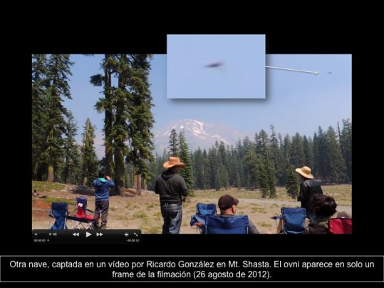"They came a long time ago from the stars and now they are on Earth living the human experience and helping with the transit.”

“Why have you kept the bodies?” I asked with a degree of anxiety.

"For this reason you will go to Altai. They will complete another episode of information. And there you will know..."

And this affirmation echoed in my mind while I contemplated the face of one of those extraterrestrial beings; it was a face which I felt like knowing...

Soon I wasn’t “looking” through the plasma bubble. If was as if this “screen” had grown. It was as if I were inside of it. I was no longer in the Guides’ ship!

“What is going on,” I asked myself as my heart raced. “I am here Nordac.” I heard Emuriel’s voice

Then I became aware of my surroundings: I was in a “hangar” or an enclosure of the ship of the 32 masters. How did I get there? There was a strange silence that was even more penetrating than inside the ship….I could breathe perfectly well and see everything clearly because the place was well well-lit. I walked toward the crystal urn that I recognized and in it I found Emuriel - “sleeping” in suspended animation.

“Tell everyone that they should be united. That they need to trust in their ability to do everything they need to do. You are here as a representative of your brothers and as it has been on other occasions, the message will reach the person for whom it is destined. Don’t worry about anything. You are not alone. Now look, go back.”

And in an instant I was once again standing in the middle of the ship... Antarel looked with an extraordinarily “human” expression of happiness while Anitac held the black cube—which had returned to a “solid” state—in her right hand. The experience had ended…..

I couldn’t believe it….”How had they done this? Did they open a portal that was part of the ship?” I asked myself.

“You never moved from here,” said Antarel smiling. “You were there but you didn’t move from here.”

“It wasn’t real?” I asked the Guide disconcerted.

“It was real, Nordac. But you didn’t move from the ship; you were always with us. This is what we had explained earlier to you before about dimensional doors.“

“It seemed like a xendra,” I said.

“Yes but what you lived was another type of experience,” Antarel hurriedly explained. “You will understand later... Don’t forget that you are multi-dimensional beings. We only artificially precipitate something which you will be able to do without technology when you awaken.” “It is time for you to return, he continued. Your brothers in the group have been with you, backing you up you. We have been with them.”

For some reason, I “knew that this experience had taken place in Shasta with the presence of three ships. I was in one of them. The other two were in the area providing support for everything.

“You know that we also possess a base here,” said Antarel as he walked slowly toward me.

“Begining next year, you will have another period of silence regarding physical contacts brother,” he said pensively. You should understand by now that to make physical contact with you there are a series of mechanisms beyond our will.

“I am going to miss you,” I told him a bit sadly.

“You won’t see us only for some time but we will keep monitoring you. We will maintain the communication and you will have all proof of our presence. But now you need to concentrate on what is to come. You have enough information to know what to do... We will be with you on Lake Titicaca and also in Chilca, Talampaya or wherever you gather on September 21.”

And then the giant from Alpha Centauri placed his immense right hand on my left shoulder and said:

“We are going to leave you on the ground. Close your eyes so that the bright light won’t damage your eyes. The light is stronger here inside. When you no longer feel my hand on your shoulder it will be the time. Are you ready?”

I didn’t want to tell him that I was ready…..I wanted to feel him a bit more…Meanwhile Anitac, who was silent throughout the experience, looked at me smiling as if saying goodbye….

“We are always be with you,” repeated Antarel once again. The energy of this experience will accompany you so that you can remember everything that you have been shown, including our conversations and what you have felt. After resting, because you need to assimilate the encounter, write it down and share it. Those who read your testimony about your experience with us will feel as if they had been here. They will also experience this contact because we have spoken to all of them through you….”

“See you soon, our beloved brother.”

So I closed my eyes and announced confidently: I am ready!

The Return

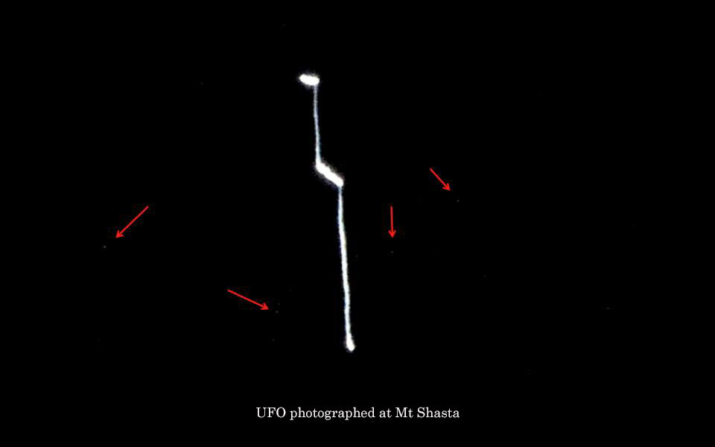

As soon as Antarel took his hand off my shoulder, I was penetrated by a bright light and felt an abrupt movement pulling me down… In an instant I had been deposited back at Sand Flat... I appeared on my feet but had no balance and was dizzy. I felt tremendously bewildered…I almost didn’t recognize the spot. It seemed as if the experience inside the ship had been what was “real” and that my location in the woods of Shasta was part of a dream….

I didn’t know where to walk…And it was hard for me to walk…I felt my body tottering and had an odd sensation of nausea with a headache. The sensation was only physical: emotionally speaking I was happy. I felt full of light. I was happy for everything I had lived, for the group, for everything. A positive energy of brotherhood had remained with me after having been with the Guides. I heard the mantras of the group, which I used to guide myself and return to my companions.

When I arrived I looked different to them. Many of them didn’t even recognize me. Some even thought that a Guide was approaching- that it wasn’t me. When I was very close they could identify me and Raul Dominguez gave me a big hug because he saw that I was having some trouble walking. The entire group was excited and hugged me too. I was moved by this and thanked them for all the work they had done while I was with the Guides, which I estimated took about 1:30 h. But the guys told me that I had been gone between 15 and 20 minutes. How was that possible? I asked them how this could be and Raul looked at my watch, which said 10:25 pm. Then the group checked their watches and cell phones and found that their devices showed one hour less.

I was exhausted and sat down on one of the folding chairs while everyone told me that the first ship that we observed—which appeared at 9:00 pm—surrounded them and was with them for several minutes; later, a second ship appeared. It moved in the vault of heaven becoming stationary over the group to accompany them during part of their work. They also saw another object, which moved in the sky over me when I was walking toward them...

I shared as much as I could with them about what had happened. I told them a few of the things that the Guides had transmitted, including the inter-dimensional interview with Emuriel while inside the ship…When I excitedly recounted the moment that Antarel touched my chest, a new ship appeared behind me for all to see. When Luis Ochoa (Napa Valley) heard my story about the “children” that I had encountered in the woods before going up in the ship, he told me that same evening, in Shasta, he had fallen asleep in the van and experienced an astral body detachment in which he had seen these very same children as a being told him: “*Take care of the children*…” Everything seemed to have been written.

Then I told the group that our experience in Shasta was over and that we could leave. And one last ship appeared; it was very bright and big and its light spread over the top of the pine forest. It was impressive. It was also incredible that after closing our work session with a few words of thanks to the Guides for their support, another very strong “supernatural” wind came over the group. It was as if we were being “swept away;” it was if ‘something” was generating this from above. It was there for an instant and then “that” was gone…..

Lorena Dominguez gave me a big hug before we got in the van and told me as she held me close: “*I want to feel the energy of the Guides now that you have been with them*.” Curiously, minutes later, Lorena became very dizzy and developed a minor headache that kept her from going to work on Monday. Some members of the group felt very thirsty that night, as if they were dehydrated. Perhaps this was a consequence of our exposure to high energy levels. We all remain strongly affected by these events. With had a feeling of peace and inner light, of happiness but also of commitment with the message.

Upon returning to Fairfield —the city where we were staying at with Raul Dominguez and his wife Lorena (just one hour from San Francisco) I looked at my e-mail and was happy to discover that my friend Luis Fernando had had a beautiful experience in Illimani that was just as we had been told in the Sajama. And I know that other brothers and sisters have also had important experiences during the “scheduled” month of August. I know that the Guides have done things this way for us to work together to solve the puzzle. No single experience is more important than another. They are all part of something greater.

Once again, I would like to give thanks to those who accompanied me during this unforgettable experience: Sol Sanfelice, Suyapa and Luis Ochoa, Alma Reyes, Lorena and Raul Dominguez, Mary Fajardo, Carlos Federico, Emilio Salazar, Maria Pascuala, Alberto Arreola and Francisco Huerta as well as to the different groups in the world with whom I spoke with prior to the experience in order to inform them of the Guides’ invitation.

I felt supported. We were one and this was everyone’s achievement. Later on I hope to share other details of this reunion with the Guides. Although it has all resulted in something way too incredible, nonetheless, they are near...

In the light,

Ricardo Gonzalez



**About the Author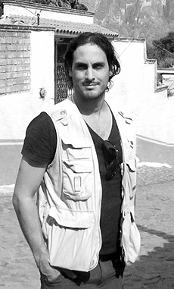.** Ricardo González was born in Lima, Peru on April 21, 1974. He is one of the most important contactees from Latin America and one of the few moving beyond his testimony by enriching it with further research. He has published 11 books about his contact experience, several of them with Ediciones Luciernaga which belongs to Grupo Planeta. Ricardo has given conferences and participated in congresses in more than 40 countries, among which are Switzerland, Italy, France, Spain, Canada, the U.S., Mexico, the Dominican Republic, Colombia, Brazil, Chile and Argentina. He is frequently interviewed by well-known radio and TV shows on an international level. Furthermore, he made inroads conducting and producing "Enigmas" for Channel 13 in Asunción, Paraguay, a show that won the Parana Award as the best research-based program.

Ricardo has traveled around the world several times, researching "impossible" power places like the pyramids in Mexico and Egypt, the Gobi Desert in Mongolia, the Mato Grosso jungle in Brazil, Tayos Cave in Ecuador or the enigma of "Paititi." He has been in contact with extraterrestrial beings since being an adolescent, whom he declares to have seen physically either alone or accompanied by other persons. He even asserts to have been inside their space craft. His testimony is recognized not only by his experiences as per the UFO phenomenon, but mainly due to the expeditions he undertook to reach several places on the planet in order to connect with a society of wise intra terrestrial individuals. This is an enigma that as of today remains alive in old Buddhist legends that speak about “Shambhala.” As a result of these experiences, in 2001 he received information about the 13 Solar Discs from the White Brotherhood, and shared this around the world, including information about a lost city called "Kayona" and which is located beneath the ice in the Antarctic Continent.  Ricardo González currently lives in Buenos Aires, Argentina.   His main website is: www.legadocosmico.com

**References:**

Link with images from our trip to Mount Shasta: http://tinyurl.com/opbdjpf

Link with the information received at the Gobi in relation to the Rock of Chintamani (2007):

http://tinyurl.com/qzql8zf