

Awakened Humanity & Exodiplomacy

Karen Kael, September 4, 2013

Abstract

Individuals and small groups of impassioned citizens have long influenced the course of events through standing up for what they believe is right -- in repressive and also in democratic societies when elected representatives, for various reasons, fail to represent the interests of those who elected them. In the extraterrestrial arena, since at least 1947, military and global elite special interests have exercised a controlling influence over elected representatives, virtually mandating that “awakened” citizens step in on behalf of the greater good. Those who acknowledge the undeniable existence of extraterrestrial intelligences are at the forefront of Earth’s destiny to join the interstellar community and at the vanguard of the evolution of humanity. Revolutionary change begins with just one voice. Citizens transforming their consciousness and empowering themselves as exodiplomats are those who will lead and help the rest of humanity navigate through the chaos, the fear and the inevitable confusion as we take the inevitable and exciting steps toward open contact.

Introduction

This essay explores perspectives on “awakened” humanity, the qualities inherent in that characterization and the role such humans might play in initiating citizen diplomacy with extraterrestrials. It also considers what right minorities and individuals have, in democratic societies, to influence the future of the planet through such diplomatic initiatives.

Individuals and small groups of impassioned citizens have long influenced the course of events through standing up for what they believe is right -- in repressive and also in democratic societies when elected representatives, for various reasons, fail to represent the interests of those who elected them. In the extraterrestrial arena since at least 1947, military and global elite special interests have exercised a controlling influence over elected representatives, virtually mandating that awakened citizens step in on behalf of the greater good.

Our lives begin to end the day we become silent about things that matter. (Martin Luther King, Jr., 2013).

Our Right, Our Destiny

In the introduction to his newly published Galactic Diplomacy, Getting to Yes with ET, Michael Salla (2013) suggests that exopolitically aware citizens have three choices: One, to trust governments to do the right thing, allowing urgent economic contingencies to soak up their attention. Two, to expose government agreements involving extraterrestrial life and pressure authorities to disclose all they know. Three, and most proactive for those citizens who are most disheartened by the depth of deception of national security authorities, to become active in citizen-based outreach with extraterrestrial civilizations visiting our planet.

Those who recognize and acknowledge the undeniable existence of intelligent species beyond Earth are at the forefront of our destiny to join the interstellar community. Those who, beyond this basic awareness, have, additionally, an awakened consciousness are at the vanguard of the very evolution of humanity. It is the role of awakened members of humanity to work with well-intentioned and willing extraterrestrials, whether consciously or unconsciously -- during sleep, for example -- to help determine with whom it is in our best interests to establish relations and to prepare the rest of the global population for the inevitability of open contact and the immense paradigm shifts (Dolan and Zybel, 2010, Chapters 7 & 8) that will result in virtually every field of human endeavor. It is our role, singly and in groups, to initiate diplomatic relations and to use our imaginations to create the vision of an exciting future in an entirely new world. This is how we demonstrate our readiness and suitability to practice galactic diplomacy and how we help to pave the way for all of humanity.

Citizen, also referred to as track II or multi-track, diplomacy has earned broad and official acceptance for making valid and valuable contributions in our world. It is an informal diplomacy engaged in by non-officials (citizens) as intermediaries in an attempt, as described by Diana Chigas (2003),

… to provide an environment that is low-key, non-judgmental, non-coercive, and safe, and to create a process in which participants feel free to share perceptions, fears and needs, and to explore ideas for resolution, free of the constraints of government positions. The process is designed to encourage the development of mutual understanding of differing perceptions and needs, the creation of new ideas, and strong problem-solving relationships.”

Extraterrestrials are choosing with whom they would like to pursue diplomatic relations as well, and this definition would characterize the clearest of these interactions. There is increasing contactee evidence that extraterrestrials whose goal is to support humanity’s surviving and thriving (and transformation of consciousness) are choosing those who are “awakened.” Less well-intentioned extraterrestrials have in the past chosen to negotiate with those who have special interests (military, corporate, etc.); however, the threats to our global well-being carried by these secret agreements appear to be on the wane.

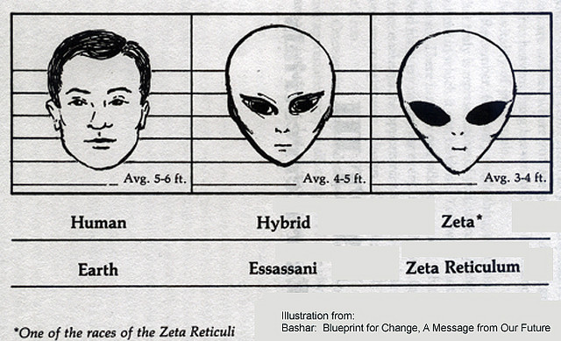
Abundant help is available. We need only ask. Though extraterrestrial observation, contact and support have been occurring throughout the history of our planet, the channeled Essassani called Bashar has said that December 21, 2012, marked the end of what has often been called the quarantine of Earth (Anka, 2012). Our conditioning can continue to make it appear as though it is still there, but the veil of separation and forgetting has been lifted. Though open contact will not be forced upon us or take place before we, as a global population, are truly ready, there are no longer restrictions on extraterrestrials responding to those of us who are asking for inspiration, counsel and even direct contact as we pursue our ambassadorial roles. It is the most exciting of times, and we are center stage, the cosmic spotlight upon us.

Asleep, Distracted or Awake

What does it mean to be not only aware but awakened? Michael Salla, founder of ExopoliticsInstitute.org, defines awakened humanity as those who represent the Voice of Gaia (Salla, 2004). Manuel Lamiroy, member of the Institute’s Research & Education Advisory Board, suggests that “awakened humanity includes societal and global transformers who introduce new modes of communicating and interacting, not only between humanity but between sentient species and the planet herself. These individuals have much power due to the progressive ideas they stand for.”

To be awakened not only suggests that one has not been lulled into sleep by the mass consciousness but also embodies a certain elevated level of awareness. To realize that our planet is a dynamic, living entity and we need to care for it is pragmatic in that it supports our very survival; however, such an attitude may or may not suggest an enlightened consciousness. Values can come from a clear-eyed objective analysis of a situation, such as the sustainability of our planetary environment, but what is truly meaningful and has impact is when values come from the heart.

Ultimately, our planet can and does take care of itself, or put another way, Gaia can take care of herself. Earth has taken hits from asteroids and exploitation from people but is fully capable of recovering and surviving, although one grim but very real possibility is that recovery could be in a post-human-presence future. Other intelligent and sentient species (cetaceans, animals, birds, etc.) on the planet present humanity with the ability to nourish ourselves physically and with the opportunity to explore choices and consequences; however, these beings can also choose to leave, as many who are now extinct have done. It is when we truly appreciate Earth and all of its inhabitants and are stewards out of love that we demonstrate that we are truly awakened. I read, though do not now recall which extraterrestrial said it, that the way civilizations treat their elders, disabled, homeless and prisoners is being observed as an important indicator of preparedness toward becoming members of galactic society. This would suggest awakened as a practical perspective and a progressive stance and also an enlightened awareness of the value of all life, without exception, and a genuine caring for the welfare of all.

Extraterrestrials also suggest that we make a practice of interacting with people who are very different from us and learn to communicate with other species (cetaceans, animals, trees, for example) on Earth. This not only helps prepare us for the alien-ness of extraterrestrials but also reinforces our sense of Oneness with all of creation. The Oneness awareness that is realized by those who are awakened and is vital for citizen diplomats with extraterrestrials has been expressed by Steven Greer in this way:

As there is one God which manifests one creation, so there is one God which is the source of all conscious beings, whether on earth or elsewhere. The great Universal Intelligence has sent a ray of this light of consciousness throughout all conscious beings, and we are united to God and to one another through its subtle and all-pervading effect. It is for these reasons that I state that the reality of man and the reality of other extraterrestrial peoples are one. Viewed with the eye of differences, we are diverse and unrelated, but viewed with the eye of oneness, we are more alike than dissimilar, more kindred than alien. And so it is that we must look to our inner reality to find not only our oneness with our fellow humans, but our oneness with other intelligent life in the universe as well. While ephemeral differences may confound us, our essential oneness in consciousness will never fail us. For there is one universe inhabited by one people, and we are they (Greer, 1991).

I would further define truly awakened humanity as those who know themselves to be equal. Perhaps different from, less consciously aware in some respects and less technologically advanced than many extraterrestrials but nonetheless equal. Not seeking gods, not wanting someone else to be responsible and solve humanity’s problems for us but willing and prepared to collaborate as allies and negotiate as equals.

The channel Lyssa Royal has written:

We are entering an age now where we no longer need to be victims of extraterrestrial contact for it to enter our reality and be validated by the masses. This coming of age requires us to be participants of contact. This is a phenomenon that will enter the life of every human at some point in the future. It cannot be denied. It cannot be ignored. And it certainly cannot be put off forever. The day will come when we must accept and acknowledge our own evolution by entering species adulthood and becoming responsible galactic neighbors. The only way we can transcend the stigma of being “victims” of ET contact is by willingly initiating it… By willingly engaging the extraterrestrials in open contact, we as a planetary species send out a beacon to the universe proclaiming our rite of passage – our coming of age into a galactic community of which we have always been a part but are now beginning to consciously recognize (Royal & Priest, 1993, pp. xv-xvi).

As we must become a global community prior to joining the interstellar one, in addition to reaching out to extraterrestrial races (i.e., contact field work), we must also embody enlightened values and channel our efforts into facilitating the planetary shift into expanded awareness necessary for our visions to come to fruition. Individual roles will naturally vary according to our unique interests, education, skills and, I might add, life themes, soul blueprints and galactic family connections. Historians, educators, researchers, writers and publishers, whistleblowers, journalists, witnesses, visionaries, contactees, experiencers, website creators and administrators, legal professionals, channels, telepaths, psychics, scientists (hard and soft), linguists, speakers, event planners, financial donors, film and television professionals, activists in various capacities all have important roles in exodiplomacy.

There is no passion to be found playing small, in settling for a life that is less than the one you are capable of living. – Nelson Mandela (Nelson Mandela Centre of Memory, n.d.).

How to Facilitate the Planetary Shift? Love is the Bridge.

If you want something really important to be done you must not merely satisfy the reason, you must move the heart also. ― Mahatma Gandhi

To return to the importance of diplomacy as coming from the heart, it’s key to be aware that love is the bridge not only among humans but also and especially among beings with vast differences of form, formlessness and expression. Throughout existence, forms or lack of them, behaviors, means of communication, values, lifestyles, religious or spiritual perspectives, everything imaginable and unimaginable might differ but there seems to be a unifying element in all of creation and that is the fact that we are all connected, with love as our essence.

Someone once asked Sasha, channeled by Lyssal Royal, this question:

From your Pleiadian point of view, what type of contact with us do you value? What excites you more – physical, face-to-face contact or nonphysical contact?
Sasha: The most exciting type of contact for us is one that makes an emotional connection with you. This would encompass physical contact and dreamstate contact. It really depends on the individual’s contact scenario. We value emotional connection, by which we mean the emotional connection of equals. We are not excited about an emotional connection with a species who sees themselves as children and us as parents; that is a relationship of need (Royal & Priest, 1993, p. 59).

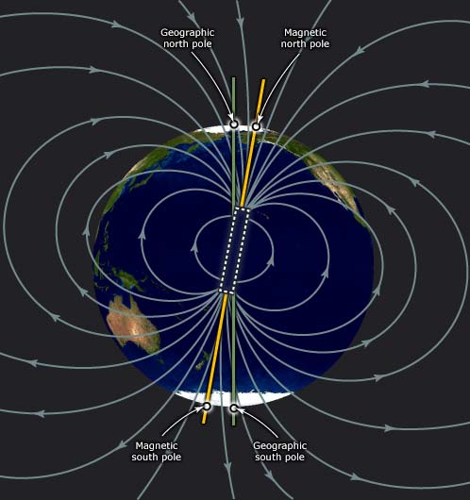
While there is a lot we don’t know about consciousness, one thing we do know is that it is made of energy, and that energy includes magnetism. We are electromagnetic beings swimming in an electromagnetic sea of energy. A growing body of evidence suggests that Earth’s magnetic field plays a powerful role in connecting us with one another, as well as the planet. If a large enough percentage of the world’s population were to focus upon one emotion during the same period of time, it could affect the planet (Magnetic Fields, 2013). The GCP (Global Consciousness Project) is privately funded through the Institute of Noetic Sciences and describes itself as an international collaboration of about 100 research scientists and engineers. Research conducted by Roger Nelson and his team at Princeton University for the Global Consciousness Project utilized a worldwide network of random numbers generators and their findings provided convincing evidence that human consciousness and emotionality create or interact with a global field, which affect the randomness of the electronic devices (Alexander, 2009).

The scientific research most focused on demonstrating that heart-based emotions are capable of affecting Earth’s magnetic field is being conducted and encouraged by the Institute of HeartMath, founded in 1991 by Doc Childre (Alexander, 2009). Childre believes that our planet is in a rapid shift that creates a lot of stress, which is necessary for the transition from brain-based awareness to heart-based awareness. It is the heart, a sense organ and not merely a pump, that modulates brain function and perception. HeartMath has developed simple tools to help people learn to catch chaotic emotional waves and transform them into coherence (medically termed psycho physiological coherence), which is the harmonious flow of information, cooperation and order among the subsystems of a larger system that allows for the emergence of more complex functions. It’s a dynamically stable state, out of which sensitivity to another level of information arises or, it could be said, increases contact with the Higher Self. It expands access to higher consciousness tools, another dimension of intelligence that makes life easier. Research at HeartMath Institute has shown that emotions not only create coherence or incoherence in our bodies but, like radio waves, also radiate outward and are detected by the nervous systems of others in our environment. There is strong evidence of a social effect and then a global effect when large numbers of people create similar outgoing waves.

The Power of a Collective

A small body of determined spirits fired by an unquenchable faith in their mission can alter the course of history. ― Mahatma Gandhi

Humanity lives in Earth’s magnetic field, and strong human emotions can modulate this field, for better or for ill. Not only can planetary stress waves be created -- as demonstrated by magnetic field detectors (geostationary operational environmental satellites orbiting Earth) on September 11, 2001, when the attacks on New York’s Twin Towers and the Pentagon occurred -- but we can also, collectively, create planetary coherence waves. The HeartMath Institute launched the Global Coherence Initiative, a science-based, co-creative project, to unite people in heart-focused care with the intention to facilitate the shift in global consciousness from instability and discord to balance, cooperation and enduring peace (Global Coherence Initiative, 2013). There are three GCI monitoring stations -- in Saudi Arabia, England and California, with a goal of 14 stations to get a complete view of what’s happening to the planet on an energetic level.
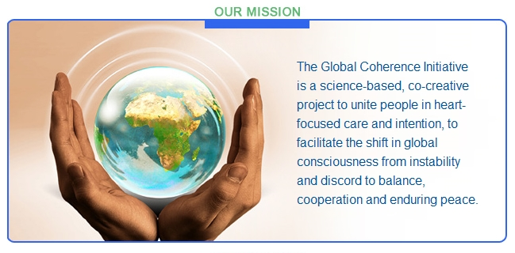
HeartMath sells the Emwave2, a biofeedback-type device, for people to train themselves in coherence, and there are currently 53,990 registered members participating in the project. While the Maharishi Effect and Yogic Flying (forms of levitation) have been demonstrated to positively impact societies in various ways and are very exciting in their potential (Maharishi’s Programmes, 2013), the possibility of a larger segment of the world’s population practicing greater coherence through focusing on feelings of love and appreciation is perhaps greater than that a critical mass will master deep levels of meditation.

During a channeled workshop in 2005, Bashar offered an example of collective impact in response to this question:

In the last workshop, you talked about a piece of art you created representing 27 worlds you were having first contact with. On each planet in real time is reflecting the impact of your contact with other worlds. My questions is, what impact on our collective consciousness did our workshop have?

Bashar: 557,000 children will now no longer experience the degree of limitation they would have had this workshop not occurred. So thank you. That’s not the only effect but that’s one that gives you an idea of the understanding of what kind of effect these kinds of interactions and gatherings have. 557,000 children on your planet will now not need to experience a certain kind of limitation anymore and it will allow them to become more quickly, more rapidly as they grow more of who they truly are and be stronger beacons of light that will then give more opportunities to others who come into their presence to also feel a higher vibration than they otherwise would have had those children had the limitations imposed upon them that they now no longer will have (Anka, 2005, disk 4, track 10).

How to respond to criticism that it is undemocratic for a minority, whether by natural evolution or awareness, to influence the future of the planet through citizen initiatives? With the words of 16th U.S. President Abraham Lincoln: “We the people are the rightful masters of both Congress and the courts, not to overthrow the Constitution but to overthrow those who pervert the Constitution.”

In his keynote address at the Extraterrestrial Civilizations and World Peace Conference in Hawaii June, 2006, the Hon. Paul Hellyer asked:

What are the consequences of the long-time cover-up of extraterrestrial intelligence and advanced technology? It appears that government has passed from elected accountable representatives of the people to an unelected, unaccountable elite group of senior government officials and industrial leaders, a military-industrial complex whose agenda is incompatible with the needs and desires of the population at large. At least that is my unshakeable conviction.

It’s up to us. People have chosen various roles in powerfully initiating citizen diplomacy with extraterrestrials. Just a few examples of these can be found in the Declaration on Peaceful Relations with Extraterrestrial Civilizations (2006), Earth Transformation Declaration (2007), Declaration for the Creation of a European Agency to Study UDOs and Extraterrestrial Affairs (2009), Galactic Freedom Day Declaration (2008), Declaration for Citizen Contact Councils (2008), Statement of Aspirations and Code of Conduct for Extraterrestrials Interacting with Earth (Salla, 2003), Galactic Diplomacy, Getting to Yes with ET (Salla, 2013), Planetary Activation Groups (Nidle, n.d.), the Stephen Bassett-driven Citizen Hearing on Disclosure (2013), Lyssa Royal’s 2013 Contact and Consciousness Retreats in Arizona and Japan, and CSETI’s CE-5 Initiative and Disclosure Project. Increasing numbers of small groups are empowering themselves as citizen diplomats.


The Power of One

I claim to be no more than the average person with less than average ability. I have not the shadow of a doubt that any man or woman can achieve what I have, if he or she would make the same effort and cultivate the same hope and faith. ― Mahatma Gandhi (Mahatma Gandhi, 2013)

As challenging to our patience and optimism as it might be to understand that before humanity can officially meet our neighbors, join the galactic community (often referred to as the Association of Worlds or Federation of Worlds), receive knowledge and technology that could help alleviate human suffering and repair the damage to our biosphere and numerous other benefits, including perspective into our origin and purpose, we simply must become a peaceful, global community. Clearly, as long as we continue turning to violent conflict to settle differences, it is inevitable that new technologies would be used for weaponry that could threaten not only our own planet but the stability of the entire solar system. With the state of the world, and particularly the Middle East, being what it is, despair might be a reasonable response by anyone who feels ready for this next step in our human evolution; however, even solutions that are predicated on ongoing conflict rather than a complete shift in global consciousness are worthwhile and important steps toward the goal and offer much reason to hope (Salla, 2004).

In a study that could be encouraging for humanity, Stanford University primatologist and stress researcher Dr. Robert Sapolski, while studying the impact of hierarchy on stress hormone levels among wild baboons of Kenya, observed one troop’s shift, in one generation, from stratified and aggressive to peaceable and nurturing. What triggered this profound change was that nearly half the least socially connected males, including every alpha male, died from eating tainted meat in a garbage dump. With only the non-aggressive males and now twice as many females, the atmosphere of the troop was completely transformed. As new, typically aggressive adolescent males joined the troop, within about six months they learned that their behavior was unacceptable and were assimilated into the new way of being, with low levels of aggression and high levels of social affiliation, a resultant lessening of stress hormone levels and a better experience for all. Sapolski believes that “…if baboons can transform, in one generation, textbook social systems ‘engraved in stone,’ we don’t have an excuse when we say there are certain inevitabilities about human social systems” (Sapolski, 2012). Although eradicating the majority of the aggressive males in the world might produce a similar result, obviously we are choosing alternatives like those being discussed.

At the time I was arrested I had no idea it would turn into this. It was just a day like any other day. The only thing that made it significant was that the masses of the people joined in. --Rosa Parks (Rosa Parks, 2013)

A rather graphic illustration of exponential spread is the story told to French children in which they imagine a pond with a few water lily leaves floating on the surface. The lily population doubles in size every day and if left unchecked will smother the pond in 30 days, killing all the other living things in the water. Day after day the plant coverage seems small and so it is decided to let it grow until it covers half the pond. The children are then asked on what day that will occur. They discover that it will be the 29th day, leaving only one day to save the pond (Meadows, Donella, Randers, and Behrens III, 1972, as cited in Porritt, 2005).

There is currently a groundswell of citizen protests against genetically engineered foods and GMOs (genetically modified organisms) and specifically against the giant Monsanto Company. California’s Proposition 37 in favor of GMO food labeling failed by a narrow margin but greatly expanded national and even international awareness of the issue. Founder and organizer of the “March Against Monsanto” movement, who created a Facebook page February 28th calling for a rally against the company’s practices said, “If I had gotten 3,000 people to join me, I would have considered that a success.” Instead she said an incredible number of people (more than two million marched against Monsanto) responded to her message and turned out to rally. Protests were held in 52 countries and 436 cities. The U.S. Food and Drug Administration does not require GMO foods to be labeled, and this spring the U.S. Senate overwhelmingly rejected a bill that would have allowed states to require the labeling (NYDailyNews.com May 27, 2013). Nonetheless, citizens are protesting, and large chain stores and suppliers, i.e., Whole Foods, WalMart, Starbucks, Target, Yoplait, Dannon, Ben & Jerry, are responding with Verified Non-GMO labeling and the withdrawal of GMO ingredients.

Conclusion

The impulse toward ever greater freedom and self-determination is undeniable in humanity and in the most awakened of us an embodiment of goodness, truth and beauty that expresses the very foundation of creation. Ordinary citizens, a very few quoted here for illustrative purposes, have sparked revolutionary changes throughout recorded human history. They have done it without practicing or advocating violence, without bullying, without imposing their will upon the majority but rather by declaring and standing up for what they knew in their hearts to be right and true. They empowered themselves with their own authority. They felt not only the right but also the responsibility to act on their visions for their own lives and the betterment of the world.

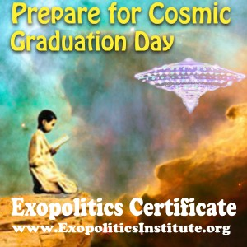
The future of our planet and our species and the building of productive, rewarding relationships with life forms beyond our Earth is up to us, citizens “without distinction” but awake and aware. It’s not up to governments, most of them ignorant or denying the existence of extraterrestrials or at the very least waiting for the United States to act, and we certainly should not leave it up to the military-industrial complex, with its self-serving special interests, apparently poised to make extraterrestrials the next enemy in order to support their ever-inflating budgets. We do not yet know how open contact will begin, perhaps with a worldwide version of the Phoenix Lights that people will simply not be able to ignore or deny, perhaps another way. However, we can feel the anticipation building, we know it is coming. It is the citizens transforming their consciousness and empowering themselves as exodiplomats who will lead and help the rest of humanity navigate through the chaos, the fear and the inevitable confusion as we take this inevitable and exciting next step in our evolution.

Revolutionary change begins with one person, one voice, one choice. One voice ripples out. A tone sounds and the vibration builds. Another hears the call and adds to it. The notes become a chord, and as more and more combine with it, a vibrational chorus. And this chorus becomes so full and rich and beautiful that it is what more and more people want to hear and become a part of and almost magically, like the lily pads on the final day, like the groundswell of citizen protests, like the escalation of citizen-initiated extraterrestrial contact, the tyranny of secrecy is undermined and the world is new.

First they ignore you, then they ridicule you, then they fight you, and then you win. ― Mahatma Gandhi


About the Author. Karen Kael has BA in Sociology/ English Literature, studied genetics at George WashingtonUniversity and earned a BA in Art and a BFA in Photography/Visual Design at the University ofOregon. She founded Buffalo Thunder, an American Indian art gallery, in Marin County,California, and is currently Creative Director at Real Music. Her lifelong involvement inmetaphysics and the new spirituality has been the inspiration for her endeavors and most recentlyled to her becoming an exopolitics activist. Under the current tutelage of non-physical entityLuma, channeled by Annie Bossingham, she is expanding her conscious communications withphysical extraterrestrials, with a goal of helping to prepare humanity for disclosure and opencontact, particularly through writing and the performing arts.


More info at: exonews.info
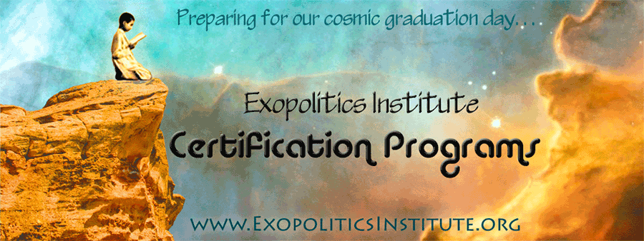

References

Alexander, W. (2009). Heartmath. Lilipoh, 15(55). Retrieved from: http://www.lilipoh.com/past_issues/2009Issues/Spring2009/HeartMath.aspx

Anka, D. (2005). Preparing for Contact 101. [Audio disk]. Altadena, CA: Bashar Communications.

Anka, D. (2012, December 21). Crossing the Threshold and Tipping the Scales. [Audio]. Retrieved from www.bashar.org/store.html#crossingthreshold

Chigas, Diana (August 2003). Track II (Citizen) Diplomacy. Retrieved from http://www.beyondintractability.org/bi-essay/track2-diplomacy

Citizen Hearing on Disclosure. (2013, April). [informal hearing before members of Congress]. Washington, D.C.

Declaration for Citizen Contact Councils. (2008, May). 2008 Earth Transformation Conference. Kona, HI.

Declaration for the Creation of a European Agency to Study UDOs and Extraterrestrial Affairs. (2009, July). European Exopolitics Summit. Barcelona

Declaration on Peaceful Relations with Extraterrestrials. (2006, June). Extraterrestrial Civilizations and World Peace. [conference]. Kona, HI.

Dolan, Richard M. and Bryce Zabel (2010). A.D. After Disclosure, The People’s Guide to Life After Contact. Keyhole Publishing Company.

Earth Transformation Declaration. (2007, May). Earth Transformation: New Science and Technologies. Dolphins Consciousness and Exopolitics. [conference]. Kona, HI.

Galactic Freedom Day Declaration. (2008). Retrieved from: http://www.galacticfreedomday.com/Declaration.htm

Global Coherence Initiative. (2013). About the Global Coherence Monitoring System. Retrieved from http://www.glcoherence.org/monitoring-system/about-system.html

Greer, S. (1991). One Universe, One People. UFO Evidence. Retrieved from: www.ufoevidence.org/documents/doc284.htm

Hellyer, Paul. (2006) Star Wars or Star Dreams? Keynote Address, Extraterrestrial Civilizations
and World Peace Conference sponsored by the Expopolitics Institute, Kailua-Kona,
Hawaii, 10 June, 2006. Retrieved from: http://exopoliticsjournal.com/vol-1/1-4-Hellyer.htm

Lamiroy, M. (Instructor). (n.d.).. Awakened Humanity & Citizen Diplomacy with Extraterrestrials.
Exopolitics 102, Lecture 8. Copyright© Michael E. Salla, PhD/Manuel Lamiroy.
exopoliticsinstitute.org.

Magnetic Fields. (2013). Peace and Conflict Resolution.org. Retrieved from: https://sites.google.com/site/peaceandconflictresolution/miracleprayerchains/magnetic-fields

Mahatma Gandhi. (2013). Gandhi led the movement to free India from its oppressive colonial rule through his own example of civil disobedience, an entirely non-violent approach that succeeded in reclaiming Indian society A+E Networks. Retrieved from: http://www.biography.com/people/mahatma-gandhi-9305898

Maharishi’s Programmes. (2013). Maharishi Effect. Retrieved from http://maharishi-programmes.globalgoodnews.com/maharishi-effect/

Martin Luther King, Jr. (2013). An “ordinary” citizen who led the civil rights movement in the United States and advanced the cause through non-violent means. He later expanded his fight for equality to poverty and the Vietnam War. A+E Networks. Retrieved from: http://www.biography.com/people/martin-luther-king-jr-9365086

Nelson Mandela Centre of Memory. (n.d.). Born in 1918, Mandela became involved in a peaceful and non-violent movement against apartheid in his 20s. During his 27-year imprisonment (1964-90) he refused to alter his position and his reputation only grew. He became president of South Africa in 1994. Biography. The life and times of Nelson Mandela. Retrieved from: http://www.nelsonmandela.org/content/page/biography

NewYorkDaily News.com (May 27, 2013). Monsanto protesters across globe rally against firm’s genetically modified food products. The Associated Press. http://www.nydailynews.com/news/national/monsanto-protesters-globe-rally-firm-genetically-modified-food-products-article-1.1355457

Nidle, S. (n.d.). Planetary Activation Groups. Planetary Activation Organization [website]. Retrieved from: http://www.paoweb.com/pagwhat.htm

Porritt, J. (2005). Capitalism as if the World Matters. London: Earthscan.

Rosa Parks. (2013). Parks is African American woman who became the “mother of the U.S. civil rights movement” the day in 1955 when, in an act of civil disobedience, she refused to obey the bus driver and give up her seat for a white passenger. The boycott inspired by her action launched Martin Luther King Jr. to prominence. A+E Networks. Retrieved from: http://www.biography.com/people/rosa-parks-9433715

Royal, L. & Priest, K. (1993). Preparing for Contact: A Metamorphosis of Consciousness. Phoenix, AZ: Royal Priest Research Press.

Salla, M.E. (2003, December 9). Statement of Aspirations and Code of Conduct for Extraterrestrials Interacting with Earth. Prepare4contact [online forum]. Retrieved from: http://www.bibliotecapleyades.net/exopolitica/esp_exopolitics_zn.htm

Salla, M.E. (2004). The emergence of ‘track two’ galactic diplomacy with extraterrestrial races. Retrieved from: www.bibliotecapleyades.net/esp_galacticdiplomacy_01.htm

Salla, M.E. (2013a). Galactic Diplomacy, Getting to Yes with ET. Kealakekua, HI: Exopolitics Institute.

Sapolski, Dr. Robert M. “Why Hierarchy Creates a Destructive Force Within the Human Psyche” on YouTube. Published on October 28, 2012 by The Symposion Nights.

