

Integral Exopolitics

Giorgio Piacenza Cabrera

ABSTRACT

Meta frameworks may not seem necessary to promote exopolitical activism, the gathering of evidence or to evaluate implications of the extraterrestrial presence but if disclosure actually occurs they will be necessary to make sense of the complex social, cultural, scientific, spiritual and psychological aspects of contact. Ken Wilber’s “Integral Theory” provides a comprehensive model (still developing) which can enhance many orthodox and non-orthodox academic fields including the emerging field of “Exopolitics.” We urgently need a shared understanding of how the entire Kosmos is organized and Ken Wilber’s “Integral Theory” – even in its current formative stage - may possess a few of the general elements of an initial “Cosmic ABC” necessary to build a much vaster scientific and metaphysical Integral Knowledge and – conceivably - a better intellectual rapport with extraterrestrials.

Introduction

Meta frameworks may not seem necessary to promote exopolitical activism or the gathering of evidence but if Disclosure actually occurs they will be necessary to make sense of the complex social, cultural, scientific, spiritual and psychological implications of contact. Ken Wilber’s “Integral Theory” provides a comprehensive model which can enhance many orthodox and non-orthodox academic fields including the emerging field of “Exopolitics.” We urgently need a shared understanding of how the entire Kosmos may be organized and Ken Wilber’s “Integral Theory” in its current stage would possess a few of the general elements necessary to build a much vaster and inclusive scientific and metaphysical Integral Knowledge and – conceivably - a better rapport with extraterrestrials. By perhaps being able to accommodate an infinite variety of perspectives under its “Five Elements” and its general guidelines, Integral Theory may also help us to harmoniously interpret many aspects of exopolitical realities and implications. Also, exopolitics should be able to inform the expansion of Integral Theory and motivate its practitioners to also become concerned about the integrally crucial issue of an intelligent extraterrestrial presence interacting with humanity which would evidently also serve to transform worldviews and overall paradigmatic perspectives about “reality.”

Because Exopolitics basically deals with the vast implications between humans and extraterrestrial intelligences within an interactive environment and ecology deals with the vast implications between humans and other living species also within an interactive environment, I think we can make a case to relate both fields to Integral Theory. Using Professor Sean Esbjörn-Hargens’ “An Overview of Integral Ecology”¹ as a structuring guideline I’ll connect some aspects of Integral Theory with Exopolitics.

In Ufology as in Exopolitics there are many tendencies or lines of attack that compete for defining their fields. This is more evident in the oldest discipline - Ufology – which is usually considered to be a search for “hard science” evidence about the ET presence but which - since the 1940’s - has also had a separate “intuitive-spiritual-qualitative” side. Although Exopolitics can already be considered as a more inclusive, “integrative” and non-reductionist approach (for instance combining methods and concepts interdisciplinarily), exopoliticians might do well to explore a content-free model like Integral Theory claimed to surpass modern and postmodern boundaries and to be applicable to enhance any particular discipline.

Integral Theory is already being used in diverse fields like psychology, economics, religious studies, community development, art and education. There also a study from the Environmental Ministry of the UK to apply it to environmental problems. If the model is universally applicable it should eventually extend into the natural sciences and even into the non-orthodox fields of “paranormal” research, parapsychology, zero-point energy and other emerging approaches (impinging on Exopolitics) that illustrate how interactions between “dimensions” or, rather, levels of reality, may occur.

Because qualitative and quantitative (pragmatic and theoretical) approaches towards “reality” often complement and supplement each other in intricate ways, we need a general framework to sort them out by connecting them in a more orderly and pragmatic way under shared transdisciplinary patterns while honoring their unique insights and methods. This is the promise of Integral Theory and its probable usefulness to any field of research and praxis.

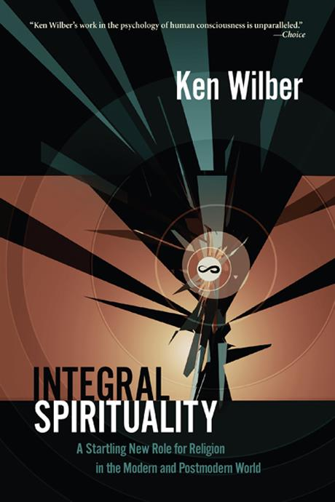
Integral Theory’s guidelines have been used by NGOs in community development projects and also within the U.N. for specific projects. Organizations like the Integral Institute, Meta Integral Foundation, Integral Research Center, Integral Life, and publications like “Kosmos” and “Integral Leadership Review” are exploring the efficacy of the Integral framework which should continue evolving to become even more applicable to all academic fields.

An “Integral Exopolitics” would provide a way of integrating multiple approaches to Ufology, and Exopolitics combined. This vision would transcend the misunderstanding of “paradigms” as basically restricted to “worldviews” in order to include their specific reality-disclosing methods or practices producing “exemplars” sustaining the world views. This may have been what philosopher of science Thomas Kuhn originally had in mind.² This may mean that the methods that disclose phenomena are as necessary as the worldviews and both are aspects of the “reality perspectives” those worldviews privilege.

Integral Exopolitics would provide a way of understanding the relationship between WHO perceives integral exopolitical phenomena, HOW the perceiver uses different methods to disclose those phenomena and WHAT is perceived as these phenomena. Furthermore, because the concept of “stages of development” is ubiquitous within Integral Theory, Integral Exopolitics would also work under the assumption that there are degrees of hierarchical complexity constantly developing under the WHO, the HOW and the WHAT.

Integral Exopolitics uses a comprehensive framework for interpreting exopolitical problems. The implications of human-extraterrestrial interactions are objectively perceived/seen and subjectively felt in the most inclusive, integral way available. It aims to develop a planet-centric and a cosmocentric cognitive and ethical embrace to understand the politics of beings that operate in a more holistic and integral way. Integral Exopolitics coordinates, cooperates with and enriches the knowledge generated in different disciplines and methods. This degree of inclusivity means that Integral Exopolitics can be: a) applied within a discipline (e.g. by integrating different theoretical and methodological approaches to Ufology and Exopolitics); b) applied as a multidisciplinary approach (e.g. by investigating exopolitical problems from several disciplines); c) applied as an interdisciplinary approach (e.g. by using social science methods to shed light on economic, sociological, legal and political aspects of concern); and d) applied as a transdisciplinary approach (e.g. by helping numerous approaches and their methodologies interface through a well-grounded meta-framework).

We Need a Higher Degree of Integration
As 20th Century maverick logician Kurt Gödel would have probably concurred, to relate with our complex, planetary-wide, state of affairs both (intelligently and consistently) we may need to perceive or envision ourselves as part of a larger “assembly” or meaningful “whole;” one including and transcending the inadequate perspectives proper to being circumscribed to a finite (and once seemingly unending) territory of cultural meaning. This “larger assembly” or “larger whole” (our emerging reference frame) would function even beyond the way in which classical physical perspectives correlate with our physical senses. It would include multiple physical and non-physical worlds. We need to understand what connects reality internally and apply that knowledge to create a more inclusive culture that educates in ways that helps individuals be less controlled by their fear-based, physical preservation instincts informing them how to organize their political worlds within the highly restrictive parameters of classical physics. We need to become much more aware of deeper, non-local, multidimensional connective principles already unconsciously connecting us with all aspects of Life as a whole.

By discovering some paradigm-connecting principles and-or principles that connect disciplines in a transdisciplinary way, some current integral visionaries (like Edgar Morin, Ken Wilber, Basarab Nicolescu, and Ervin Laszlo) are at the forefront of a crusade to discover ways of accommodating in a healthy, organized and ever-evolving manner all forms of valid knowledge. Moreover, non-orthodox “integrative” ideas in quantum physics (like David Bohm’s, John Archibald Wheeler’s, John Cramer’s, Yakir Aharonov’s and -more recently and audaciously- Claude Swanson’s and Edgar Mitchell’s) and integrative mystical and esoteric models (like those of visionaries Sri Aurobindo, H.P. Blavastky and Rudolph Steiner) may all possess important elements of truth and crucial common elements which–if carefully understood - could combine under an even grander integral vision. I called the aforementioned scientific and mystical-esoteric thinkers “integrative” rather than “integral” because –even within their wide-ranging systems - they still privileged either the materialist or the spiritualist-idealist understandings. In other words, they still privileged major aspects of Life without combining them as equally valuable.

Exopolitical Definitions
Dr. Michael Salla defined “Exopolitics” as “the study of the key political actors, institutions and processes associated with extraterrestrial life.” Dr Alfred Webre defined “Exopolitics” as “the science of relations among intelligent civilizations in the Multiverse.” Investigative reporter Paola L. Harris has used combined definitions like “the convergence of a new interdisciplinary science, an international political movement and a new paradigm, which all deal with the wide range of implications of extraterrestrial life” and “the study of contact and relations between humanity and extraterrestrial civilizations.” Finally, Dr. Rebecca Hardcastle defined the intimately connected field of “Exoconsciousness” as “the study, practice and applications of the extraterrestrial origins, dimensions and abilities of human consciousness.”

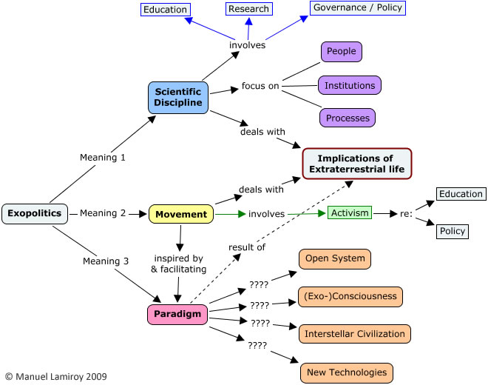
For me, the integrality of “Exopolitics” became obvious when in October, 2009 it was more formally and consensually defined by various advisors from Exopolitics Institute as “an interdisciplinary scientific field, with its roots in the political sciences, that focuses on research, education and public policy with regard to the actors, institutions and processes, associated with extraterrestrial life, as well as the wide range of implications this entails through public advocacy and newly emerging paradigm” and as “the convergence of a new interdisciplinary science, an international political movement and a new paradigm, which all deal with the wide range of implications of extraterrestrial life.” ³

Thus - as a whole - Exopolitics promotes a respectable, integrative, multi-paradigmatic, interdisciplinary approach to deal with the paradigm-changing, planet-wide issue of the extraterrestrial presence on Earth. The way it is developing seems to progressively include more valid ways to perceive reality gradually becoming more inclusive. This is good and not another form of reductionism but gradually needs to go farther.

I think Exopolitics is part of a general emergence within increasing segments of humanity eager and able to embrace non-reductionist, connecting models and an awareness urgently needed to save the planet from pre-integral levels of awareness offering piecemeal solutions. The next stage would be not just about using valuable concepts, methods and findings from other academic disciplines and integrative insights. It would be about integrating with the integrative models and regular academic disciplines by finding the patterns under which all of them and exopolitics exist. To enhance the study of exopolitical implications as per the ET presence, the next stage would be to develop an “Integral Exopolitics.”

The Transcendental Pattern
I’d say that Integral Theory ultimately derives from very profound metaphysical organizing principles that define the boundaries between duality and non-duality. Introducing a distinction between undifferentiated being and the illusion of non-being gives rise to “Holons” or part-wholes which are simultaneously complete and incomplete structuring entities expressing under the combined “dimensions” of “oneness,” “plurality,” “self” and “other” which combine to express the “Quadrant” or four major irreducible ontological and epistemological “perspectives.” These “Quadrants” themselves seem to be expressions of a Trinitarian Organizing Principle also generating the 3 main ontological levels (described within Vedanta) along with 3 “logics” or the corresponding fundamental ways of reasoning: in “either-or” (mutually exclusive, excluded middle-based) terms more applicable to the Physical Realm in which objective exteriors dominate; in “both-and” (complementary) terms more applicable to the non-physical, Subtle-Mental Realm in which both the subjective interiors and their corresponding objective exteriors equally cause each other and; in “neither-nor” (mutually immanent) terms more applicable to the “seed” or Causal Realm in which subjective interiors dominate and nothing can be logically proven through objective comparisons. The “transcendental pattern” (here only very superficially detailed) unifies all forms of knowledge, all levels of the Kosmos and would also give rise to the “five elements” of “AQAL” or Integral Theory. Understanding it more thoroughly would be useful for developing a much broader integral science also capable of dealing with “paranormal” and-or “interdimensional” and inter-realm phenomena; a recurrent aspect of the “high strangeness” associated with extraterrestrial contacts and with attempts to understand what the implications of the human-extraterrestrial inter phase might be.

Four Kosmic Perspectives
According to Integral Theory (and now to Integral Exopolitics) there are at least four fundamental irreducible “perspectives” (the objective, interobjective, subjective, and intersubjective perspectives) that must be used when attempting to understand a phenomenon or an issue. These are both ontologically real and subjectively experienced in an inextricable way. In Integral Theory these four perspectives are graphically represented by four “QUADRANTS”: the INTERIOR and EXTERIOR of INDIVIDUAL and COLLECTIVE experiences and realities. Using pronouns these represent the intentional “I,” the cultural “we,” the individual behavioral “it,” and the social systemic “its” aspects of exopolitical issues and of anything arising in the Kosmos (“Kosmos” is written with a “k” to denote that consciousness and intelligence is fundamental to this organized entity).

The “objective” perspective (a combination of singular and exterior dimensions) includes the material composition and the manifest or collectively obvious, exterior behavior of individual entities like machines, and human and ET bodies. The “interobjective” perspective (a combination of collective and exterior) includes the systemic structures and exterior behaviors produced by collectives, ranging from extraterrestrial societies, human legal and political systems, and interactions between human and extraterrestrial societies, including how energetic, multidimensional systems might combine. The “subjective” perspective (a combination of individual and interior dimensions) includes feelings, personal experiences and thoughts. The “intersubjective” perspective (a combination of plural and subjective dimensions) includes the cultural norms, group values and implicit or explicit agreements. All of these perspectives co-exist and co-arise simultaneously.

Pure, non-dual Consciousness would be the basis of the existence of individual and plural subjects and objects (the four quadratic perspectives) throughout the Kosmos and ontological realities would be disclosed and co-created by epistemological experiences manifesting as individual psychologies (first person subjectivity), culture (second person intersubjectivity), behavior (third person objectivity) and systems (third person interobjective relations). This means that Integral Exopolitics would draw upon the first, second and third person experiential perspectives which individual, conscious beings have in relation to other entities and to what other entities have in relation with them. Moreover, some form of pansychism would have to be incorporated into this model as even cells and atoms would operate under the manner of coalesced intelligences organizing their self-preservation and extending associations with other entities.

The four “perspectives” would be interfaces used by a human exopolitician to disclose and interpret exopolitical issues just as extraterrestrial exopoliticians would experience their interface with humans through these same perspectives. Within the Subjective Quadrant we might have forms of psychological experiential Exopolitics like what might be called an “exo-phenomenology;” within the Intersubjective Quadrant we might have forms of resonant intercultural Exopolitics like what might be called a “cultural exocosmology;” within the Objective Quadrant we could have forms of scientific Exopolitics like what might be called a “behavioral exopolitics” and; within the Interobjective (systemic) Quadrant we would have forms of systems-based exopolitics like what might be called an “exo evolutionary ecology.”

If any of the basic “perspectives” (or ways of perceiving and of being) were fundamentally ignored we would fall into a reductionism and they would probably have to surface later on in a pathological way. Furthermore, none of what any of these perspectives disclose should be explained using the terms and methods of another. Feeling disrespected and scared upon being abducted cannot be replaced by an objective, impersonal statement such as “at 3.00AM he was paralyzed and taken by a space-time molecular modifier onboard a four density craft where he was examined.” Also, a gathering of extraterrestrials and Earth humans with their unique intersubjective, intercultural characteristics cannot be grasped under an understanding of the technologies or political and energy systems involved. In other words, the qualitative, intersubjective resonance between human and ET beings has to be seriously acknowledged.

Because everything in “reality” arises as these four “perspectives” and under these four “perspectives”, to integrally understand any kind of human-extraterrestrial encounter, all of them need to be taken into account even if this ads complexity to the challenge. For instance, in relation to subjectivity, elements like states of consciousness, levels of consciousness, beliefs, pathologies, delusions, personal attitudes, emotions, and cognitive capacities, need to be considered during human-ET interactions. In relation to intersubjectivity, worldviews, mutual resonance, rules, values, coinciding or diverging understandings, common goals, and different histories need to be taken into account. In relation to objectivity and inter objectivity, technological systems, forms of energy, physical effects, brain states, behaviors, political dynamics, socio-economic effects and even the interactive effects between different reality systems need to be taken into account.

The four basic perspectives or four quadrants also have “lines” or “capacities” that develop or evolve into various levels of complexity as, for instance, in the personal, “Subjective Quadrant”, there are cognitive, spiritual and ethical levels of development, and in the “Intersubjective Quadrant” there’re are cultural stages in which worldviews evolve. Moreover, in the “Objective Quadrant” there also are parallel or simultaneously accompanying complexifying brain structures, evolving genomes, biochemical organizations and, perhaps, a complexifying ability to handle various energy states both in human and extraterrestrial bodies. Moreover, as per the “Intersubjective Quadrant” we can speak of complexifying social systems, quantifiable production systems, energy systems, political systems, and the like.

When Non Dual Consciousness is apparently restricted by duality it would create the essential patterns of Life and the Kosmos (in fact a living Kosmos) by subdividing into the ontological and epistemological perspectives we have called “Quadrants” and every phenomenon or entity (at any level of the Kosmos) displaying these “quadrants” (or capable of being epistemologically interpreted under quadratic characteristics) would express as “HOLONS” (a term coined by Arthur Koestler basically meaning “wholes that are parts of larger wholes” or “part-wholes”). These would be universally structuring patterns capable of hierarchically connecting and evolving and simultaneously displaying the four perspectives with greater or lesser hierarchical inclusion and extent). While every (subjective and objective) ‘thing’ in the Kosmos would be holonic higher “holons” and their “quadratic perspectives” would be able not only to transcend lower ones but also to include them forming natural hierarchical structures.

Individuals would also develop following holonic patterns although, in order to differentiate themselves from one stage of evolution to the next they often engage in pathological suppression, repression and denial of previous discoveries and the cultures they generate may lose integrally useful qualities and knowledge disclosed in previous stages. This creates hidden, unrecognized “shadow” elements that are carried into the next stages and need to be healed to move on to a more integral, planet-centric and cosmocentric civilization necessary to avert ecological disasters and to enhance exopolitical relations synergistically. An integral exopolitical approach would take into account that all previous developmental stages, worldviews and discoveries are necessary even if we promote an ethic that embraces all sentient beings on the planet and beyond. While open to new knowledge, it would be a conciliatory approach toward the discoveries of the past.

While all sentient beings possess the four perspectives through which they experience, disclose and interpret their worlds, their degree of consciousness (tantamount to a general capacity to accept and administer information without repressing or suppressing it) differs significantly. Human consciousness has to become emptier, vaster or more inclusive to embrace more of reality and to resonate intersubjectively in harmony with the understandings of extraterrestrial beings. Our “semiotic niches” would need to coincide sufficiently. Without a subjective inclusivity concomitant to an exterior inclusivity we would misinterpret meanings, communicative patterns, somatic sensations, and phenomenological states by feeling uncomfortable when exposed to more complex minds and social structures.

Integral Theory is supposed to be “psychoactive” in that exposure to its organizing patterns may also promote greater levels of interiority, self-awareness and sentience. However, interacting with extraterrestrial beings capable of using a non-physical realm to create “transdimensional” effects on our experience of classical physical matter would require a form of intersubjectivity or culture that acknowledges (and is comfortable with the existence of) the non-physical, Subtle Realm, something which not only has not been developed by integral theorists thus far but which has been somewhat avoided in order to gain credibility in the academic world. So, there is much room for theoretical improvement.

We could say that Integral Exopolitics is also a mixed-methods discipline based on unifying patterns common to humans, extraterrestrials and the Kosmos. Furthermore, the practical political relation between Earth humans and extraterrestrials will to a great extent depend on the level of conscious development individuals, cultures and their leaders reach. Is their self-identity primarily egocentric (“me”) ethnocentric (“my group”), sociocentric (“my country”), worldcentric (“all of us”) or planet-centric (“all of us and our planet”)? Integral exopoliticians will have to consider that, once the leading intellectual edge of a society develops technologies representing their level of development, everyone in that society regardless of their personal levels and ethics can use them.

To develop a good rapport with ETs we need to develop our consciousness or overall capacity to hold in and process information without being unconsciously possessed by it. We need sufficient uncluttered interior “space” to accommodate more.

In relation to that idea, the concepts which Daniel Sheehan (an important exopolitical attorney, activist and thinker) presents about “8 Basic Political Worldviews” (each operating under different paradigms within the American political system) approximate some of Ken Wilber’s ideas. I’d say that, to be able to practice an advanced level of Integral Exopolitics (beyond accepting disclosure without panic), a higher percentage of the electorate would have to function under sympathetic worldviews and-or at least under what he calls the “exopolitical worldview.” However specifically espoused paradigms and worldviews would correspond to discreet levels of development (perhaps partially based on research like that of Willett Kempton, Paul Ray and Sherry Ruth and on philosophers of cultural development like Jean Gebser), as Wilber usually emphasizes the importance of the evolving capacity consciousness has to take in more perspectival information. This overall capacity would be more clearly represented by how individuals consider their self-identity and values to be. Do they primarily experience themselves defined by selfish, ethnic, national, international, planet-centric or cosmic-level ethical parameters?

The following diagram depicts the simultaneous stage-like development of elements within the four main “Quadrants” or “quadratic perspectives.”
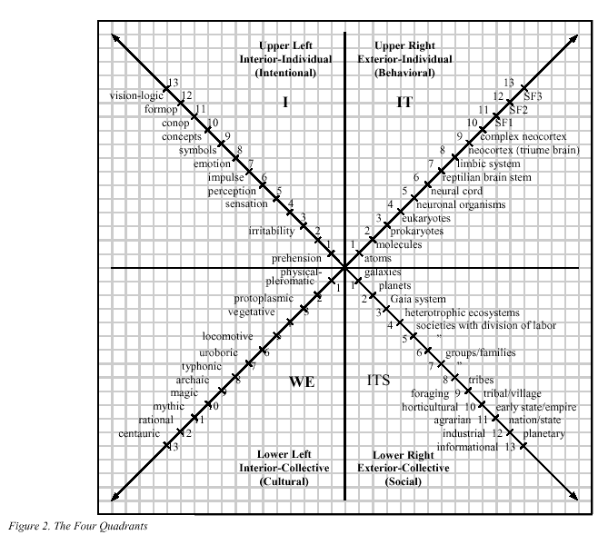
From: Sex, Ecology, Spirituality. Ken Wilber (1995)

Highly developed planet-centric levels of self-identity would be crucial to have a healthy exopolitically interactive society and, for this reason, one of the main tasks of integral exopoliticians would be to educate and to promote these higher levels of development. If a greater percentage of the world population ethically reaches worldcentric (modern and postmodern) and planet-centric (postmodern and post postmodern) identities exopolitical proposals would be more acceptable. Moreover, if biologist Rupert Sheldrake’s proposal about “morphogenetic fields” is correct and, even if every newly born human needs to progress from stage cero onwards, more of these newly born would be able to develop faster into their own highest possible levels.

The 8 Zones of Integral Methodological Pluralism
“Quadrants” can be further subdivided into their insides and outsides resulting in 8 classical and non-classical experiential and methodological “zones.” For instance, the Individual-Subjective quadrant has an “outside” amenable to objective psychological observation through psychological testing and other forms of “structuralism.” Its “inside” could be represented by the intimacy and privacy of “phenomenology.” The Individual-Objective Quadrant can be distinguished into an “outside” area suitable for classical “empiricism” and an “inside” one more related with “autopoiesis” (like aspects of the cognitive sciences). The “outside” of the Intersubjective Quadrant can be distinguished by objective observation research methods like “ethnomethodology” and its “inside” by group participatory methods like Gadamer’s “hermeneutics.” Finally, the Interobjective Quadrant has an outside which can be represented by classical ecology, sociology and Systems Theory and an inside which can be represented by what (following concepts by H. Maturana and F. Varela and N. Luhman’s) could be called “social autopoiesis.”

These “8 zones” are perspectives, ontological expressions and methodological areas and, according to Integral Methodological Pluralism, should be treated under three general principles: 1) NON-EXCLUSION (accepting in a neutral way that the data disclosed under the 8 perspectives and their associated methods are all correct given that they do not make statements about what is disclosed by the other perspectives and their methods); 2) ENFOLDMENT (all disclosures give information that is correct but partial and which can be improved by progressively more advanced disclosures in a transcend and include mode); ENACTMENT (reality is not completely independent of the knower but progressively revealed to sentient individuals through their activity of knowing it according to their perspective-taking capacities or developmental levels, quadratic perspectives and methods used). In other words, we are all conscious, co-creative participants (not parts in a mechanism) in an infinite unveiling of a Great Non-Dual Mystery which –under the guise of limitation - we also experience as the Kosmos.
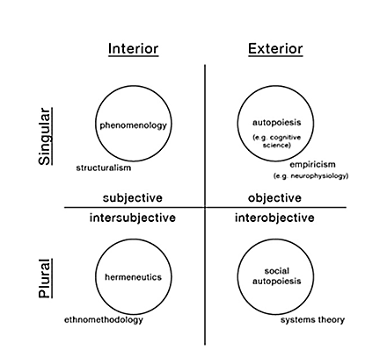
From: What Is Integral Spirituality? Ken Wilber (2005)

Validity Claims
Truthfulness/Sincerity/Integrity would correspond to the Subjective Quadratic Perspective and its methods. Truth to the Objective Quadratic Perspective and its methods; Justness/Fairness/Cultural understanding for the Intersubjective Quadratic Perspective and its methods and Functional fit/Structural Functionalism/Mutually Reinforcing Systemic Combinations for the Interobjective Quadratic Perspective and methods. These four perspectives (which also reflect the Platonic value spheres of Beauty, Good and Truth) also correspond to spirit, mind and body (or consciousness, culture and nature) and, by acknowledging every major perspectival aspect of reality and their methods under integral methodological principles, Integral Theory would be one of the first (or the first) meta theories that – at least as a set of guidelines - ceases being one more limiting theoretical approach among others. It would be more like a content-free map which (as far as it has been developed) reflects important aspects of “reality’s operating system” which includes the cognitive-disclosure spaces in which other theories unfold. It would be a way to start thinking in a more mature, ‘kosmic’ manner.

AQAL
Besides the “Quadrants” (or perspectives) and “Levels” (or stages of hierarchical complexity), there are other important “elements” which Integral Theory currently recognizes as arising (always within the four main quadratic perspectives). These are “Lines” of development (or intelligent capacities), temporary “States” (or situational arrangements which –in terms of subjectivity - include states of consciousness like waking, dreaming and deep sleep) and “Types” (or typologies like male-female, body types, personality types and, why not, close encounters types, types of civilizations based on energy use). In fact, “AQAL” means “All quadrants, all lines, all levels, all states, all types” and with its “five elements” most of reality as far as we know it (but without acknowledging inter dimensional or inter-realm phenomena) can be comprehensively understood.

In Matt Rentschler’s “AQAL Glossary” we read that AQAL “is a supertheory or metatheory that attempts to explain how the most time-tested methodologies, and the experiences those methodologies bring forth, fit together in a coherent fashion. AQAL theory’s pragmatic correlate is a series of social practices called Integral Methodological Pluralism (IMP). The personal application of AQAL is called Integral Life Practice (ILP). “AQAL” is often used interchangeably with Integral Theory, the Integral approach, the Integral map, the Integral model, and Integral Operating System (IOS).” http://aqaljournal.integralinstitute.org/public/pdf/aqal_glossary_01-27-07.pdf

What I think AQAL is missing to be more applicable to the “paradigmatic” aspect of Exopolitics is a greater inclusion of what could serve to explain the relation among realms (which also display quadrants and manifest under different “logics”). While in Integral Theory discourses “realms” are mentioned in relation to states of consciousness (the three main states of being awake, dreaming and in deep sleep would relate with the three main realms) and to some self-development, psychophysical exercises, what I have elsewhere⁴ posited as their interactive, interpenetrating and mutually immanent relations (both as actual and as potential to each other) have not been explored and mysteries like “paranormal” events and “extraterrestrial transdimensional transference” remain out of the reach of the current state of AQAL as a purported “theory of everything.”

In the modern era several researchers (like Maslow, Piaget, Loevinger, Fowler, Kegan) using structuralist methods discovered that in human development different capacities, intelligences or “lines” usually progress in “stages.” In AQAL, each general level of development is described by a color. “Integral” levels (also referred to as “Second Tier” levels) would start at “teal” color and, with their emergence, it would be the first time in history in which individuals realize that every previous level and their associated worldviews and fundamental discoveries also are valid and true. It would be the first truly inclusive level. Also, higher levels would also be more inclusive (as they are supposed to transcend and include previous levels) and their models would be truer. However since – as already mentioned - to distinguish themselves from the previous levels, people often excessively dismiss, suppress or repress findings from previous levels that should have been incorporated, we must be careful not to generate self-deceptive “shadows” that will linger into subsequent levels of development and possess us without being aware of them.

The following diagram depicts levels of development (and the colors assigned to them) as per various lines of development in the “Subjective Quadrant”
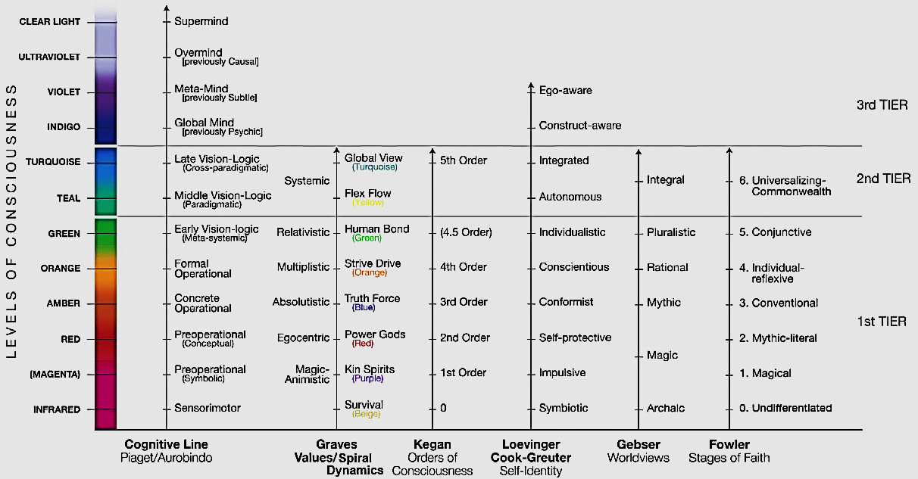
From: “Some Major Developmental Lines.” Integral Spirituality (Wilber 2006)

Holons, Levels and Connecting with Gaia
Let’s recount some of the basic ideas to move forward. While all our experiences and phenomena would be describable in terms of evolving intelligent “lines,” using adequate “states” and “types” in the domains of culture, self, and nature (thus also under the Four Quadratic Perspectives) we must take into account the findings of modern science regarding evolution and development describing more or less inclusive (and hierarchically arranged) “levels.” This is because “holons” are structuring universals through which all singular and plural objective and subjective phenomena can be understood also as hierarchically interconnected.

The fundamental organizing factor in the Kosmos would be the “holon.” Ultimately “holons” (universally applicable, organizing patterns striving between the particular and the unconditioned) would be universal, organizing expressions of the “Mind of God” functioning under the illusion of duality.

According to Matt Renschler’s “AQAL Glossary” a “holon” refers to a whole that is simultaneously part of another whole, or “whole/part.” Whole atoms are parts of whole molecules, which themselves are parts of whole cells, and so on. There are individual holons and social holons. The main difference between the two is that individual holons have a subjective awareness or dominant monad (an “I”), while social holons have an intersubjective awareness, dominant mode of discourse, or predominant mode of resonance (a “We”/“Its”): social holons emerge when individual holons commune. Individual and social holons follow the twenty tenets. Lastly, “holon,” in the broadest sense, simply means “any whole that is a part of another whole,” and thus artifacts and heaps can loosely be considered “holons.”

Because every “thing,” experience, event, concept or phenomenon has holonic characteristics (unless we eliminate heaps and piles as non-holonic, insentient aggregates that do not tend to self-preserve or to associate with each other) “holons” would be ubiquitous, unifying entities. All “things” understood as “holons” are characterized by being simultaneously “whole,” definable, unitary, identifiably distinct (with an identity-preserving tendency) and simultaneously “partial” or “incomplete” (with an associative tendency to associate with other holons in an attempt to complete themselves). They strive between being objectively definable and being subjectively indefinable and between being one and multiple. The greater a holon’s horizontal (or heterarchical) reach the greater its “span” and the more vertical levels a holon has the greater its “depth.”

Every entity has four distinct quadratic expressions and the levels in these expressions should not be confused with each other. For instance, cells in the objective quadrants may pile up with more or less complex biological units but they in themselves do not pile up with memes and ideas in the subjective quadrants of the “noosphere.”

More specifically defined levels are “… a general measure of higher and lower. While the terms “structures,” “stages,” and “waves” are sometimes loosely used to refer to “levels,” each term has their own important nuances. Any specific level has an actual structure. Levels tend to unfold in a sequence and thus progress through stages. Finally, levels are not rigidly separated from each other but are rather fluid and overlapping waves. In short, levels are abstract measures that represent fluid yet qualitatively distinct classes of recurrent patterns within developmental lines. Some examples include egocentric, ethnocentric, worldcentric, planet centric, and kosmocentric.” (Integral Glossary, Rentschler, 2013).

Levels are assigned colours. In the subjective quadrants a “red” level is ego-centric and with a warrior-like sense of personal pride and honour; “amber” is socio-centric and defined by a mythical predisposition and intersubjective group values; “orange” is modern-individualistic-rational; “green” is postmodern, egalitarian, horizontally systemic and ecological (but dislikes hierarchies as they remind of past abuses of power); “teal” is the beginner’s integral stage and recognizes a hierarchical connection and organization among systems but also begins to recognize the truths in all previous levels in a non-exclusivist way.

How might the Integral/AQAL “element” or concept of “levels” relate with the global exopolitical need to evolve beyond the dominant anachronic human developmental stages ruling the world in order to represent as “Citizen Diplomats” not just humanity as a whole but “Gaia” (perhaps our planet’s alleged sentience rather than only a cybernetic, homeostasis-seeking system) and all the sentient beings supported by ‘her’? Well, (extending the ordinary application of “levels” accepted by most integral theorists still preferring to ignore a range of vital forms of “paranormal” interaction with the non-physical, “Subtle Realm”), it seems that not only the conscious but also the unconscious levels of all biological sentient beings intimately depending on Gaia might hierarchically coordinate and interface within an interconnected “noosphere” (an intersubjective field of consciousness). All forms of sentience in this noosphere would interface with Gaia if we consider the higher inclusivity and connectivity of her non-physical, Subtle Realm counterpart. At this level where (according to Subtle Realm experiencers like William Buhlman) it seems that exterior substance (not limited by space-time parameters) directly responds to subjectivity we would see more evidence of a living planet. At this level more aspects of subjectivity are objectively represented and these would form obvious interobjective systems.

At deeper levels of (collectively unconscious) sentience, Rupert Sheldrake’s “morphogenetic fields” (normally associated with specific biological species) might form hierarchically connected, living units with Gaia’s sentience representing the larger conscious, living unit of our world. Definitely, I think that part of the reason some extraterrestrials might have for making “crop circles” in coordination with Gaia, universal mathematical patterns and symbol held in humanity’s collective unconscious would be not to impose a truth on us to swiftly awaken but to generate more self-motivated curiosity through what (for us) is an “anomalous” formative process denoting a sophisticated and intelligence possibly connected (as many anomalies in UFO events) with Jung’s “imaginal world.”

What do we need to understand beings with the power of a “Type I” civilization in the Kardashev Typology if it is not limited to a “brute force” approach to energy generation? My view is that, for our purposes of understanding ET civilizations, the Kardashev Typology remains too ‘classical’ (focused on exploiting external resources) and, while it might be partially correct (differentiating in terms of available energy levels), it seems to miss the possibility that ETs may have also learned to extract energy with less wastes and from the vacuum of space while reprogramming physical quantum probabilities by ‘transdimensionally’ using higher levels of non-physical reality, themselves also responding more directly to consciousness. In this case, an Interior, Subjective development would also accompany a Type I civilization which – in order to survive - would have the maturity not to misuse this energy source in relation with the Subtle Realm and would also normally possess a degree of individual subjective and cultural development capable of respecting, interfacing and communicating with their home planet and with Gaia. They would function under more integral, “transdimensional” and co-creative rules of engagement so as not to interfere with each other or in some specific ways with the sentient beings more permanently associated with Gaia. They would occupy (holistic and integral) levels of consciousness with which we normally participate but in an unconscious or subconscious manner.

Technological power would grow with an ability to handle it in terms of interior, psychological, psychic and ethical aspects or else it wouldn’t be stable to last. According to Integral Theory, interior development of the psychological self, is accompanied by parallel developments in culture and objective interactions with nature (including technology and social systems). Thus ETs coming to Earth would have ways to interface and coordinate with subjectivities that includes Gaia, our unconscious selves and other sentient beings in Earth’s “noosphere.” This (and their willingness to respect all extraterrestrial projects as parts of an inextricable whole) would be a factor for extraterrestrial “guardians” to allow their presence and participation (whether inclined towards service to others or to service to self). Having been historically and genetically involved with our timeline would also be factors for granting this permission.

I think that - in essence - private citizens (preferably with a planet-centric identity capable of relating to the planet as a whole and situating it in a cosmic context) can be partially adequate representatives of the ‘voice of Gaia’. Also, simple human beings not aware of “Integral Theory” or of “Exopolitics” but possessing an ethical openness and respect for Life (even some pre-modern peoples) would have sufficient integral qualities to assimilate and process some levels of information during extraterrestrial contacts. The key point might be how our conscious and subconscious interface with Gaia as a whole.

Coming from an Andean and Latin American tradition I perceive that Gaia/Pacha Mama has a subjective self in which our subconscious and unconscious subjectivities participate. Our normally subconscious and unconscious awareness in this participation perceives a living, intersubjectivity with a collective of consciousnesses coordinated by ever more inclusive conscious wholes. In this manner the distinctions between those “exterior” to the system (“extra” terrestrials) and us is lessened. The responsibility that arises is with the Good or harmony of all sentient beings involved and with promoting a healthy functional ‘fit’ of the system components interacting in these wholes.

It means that individual citizens at a planet-centric level of consciousness don’t just work for themselves, their tribes, their nations, their human species or their planet but for all those beings that participate in the noosphere and larger intersubjective unit we call “Gaia.” This also involves benevolent and non-benevolent entities in relation to our conscious thinking and freedom; ETs that (at least in some key aspects) connect with this deeper level of consciousness which means that our concept of “legal rights and responsibilities” must evolve, for instance, into an understanding of why extraterrestrial entities occasionally say that they have a “right” to abduct us, or (whether they are primarily benign or self-serving) to appear over our sovereign nation-state skies even operating bases within our nation-states’ seabed and underground. We must understand that, if they are allowed to interact with us and our planet, they operate within certain rules that reflect a more holistic and integral understanding.

The key point here is…consciousness. Specifically, what are we conscious of? How much of our subconsciousness and unconsciousness through which we are interconnected to all sentient beings has surfaced to our awareness? The more we become conscious of the deep subjectivity and intersubjectivity that binds us in an objective way with the terrestrial and non-terrestrial ‘circle of life’, the more we’ll be able to participate – from an extraterrestrial level of consciousness - as sovereign voices of Gaia and beyond. The key is to become more than aware of a holistic systems reality. The key is to become aware of how subjectivities guide and interact with those systems in mutual resonance beyond space-time through Subtle Realm patterns.

Now (as Harvard developmental psychologist Robert Kegan would say), awareness of this would mean that when what unconsciously possesses us becomes a recognized mental ‘object’ in our conscious awareness we may develop into a higher level of functioning and understanding. Professor Kegan (who also collaborates with the “Integral Movement”) mentions five “Orders of Consciousness” and that –in order to function adequately in today’s highly systemic and interconnected global society - we need to be at the higher levels.⁵

The First Order (Impulsive) would be of individuals unconsciously possessed by their impulses and the objects he would be aware of would be his even more primordial reflexes. The Second Order (Imperial) would be of individuals unconsciously possessed by their self-centered needs and the objects they are aware of would be their impulses. In the Third Order (Interpersonal/defined by the group), individuals are unconsciously possessed by interpersonal relations/need to belong and the objects they are aware of would be their self-centered needs. In the Fourth Order (Inter Institutional and akin to “modern”), individuals are unconsciously possessed by a sense of individual authorship and would be aware of their continued dependence on interpersonal relations. In the Fifth Order (Inter-Individual/multi-systemic and akin to “postmodern”), individuals would be unconsciously possessed by the interpenetration of subjects and would be aware of their individual authorship. The Fourth and Fifth orders of consciousness would accompany worldcentric perspectives necessary to start thinking in practical holistic terms as members of one humanity. I suspect that these individuals would also tend to hold worldviews a bit more compatible with the practice of Exopolitics but also think that there may be “integral” “psychic” and “spiritual” qualities available to individuals (and not necessarily disclosed by “modern,” “postmodern” and “incipient integral” psychological studies) at this and previous levels which would be compatible with consciously interfacing with Gaia in a representational manner.

At any rate, in situations applicable to the possibility of a wholesome citizen representation of ‘Gaia’ and humanity as a whole, we would have to free ourselves from some limiting subconscious prejudices and become more aware of universal, connecting principles and of the psychically interactive energies through which all sentience participates either consciously or subconsciously. Extraterrestrials would cease treating us like immature beings and cease moderating so much their interactions by primarily speaking to our deep subconscious minds.

Regarding “levels” we must be careful not to dismiss offhandedly findings discovered by indigenous tribes and pre-modern people in general because they can add to an integral understanding of reality. We must beware of taking an elitist view based on how we tend to differentiate ourselves from previous, less evolved stages of development in order to affirm our current one. We must also try not to over-romanticize pre-modern stages which in many other ways were less inclusive.

Types
Typologies are important for Integral Theory and for exopolitical analysis. We speak of types of contacts, types of civilizations based on energy consumption (Kardashev), types of civilizations based on behavior (an exopolitical assessment), physical typologies and more.

In Matt Rentschler’s “AQAL Glossary” Types are “horizontal styles available to any developmental level within the quadrants. Examples of types include Myers-Briggs, Enneagram, masculine and feminine in the Upper Left; body types in the Upper Right; cultural types in the Lower Left; and types of biomes in the Lower Right.”

In Sean Ebsjorn-Hargens’ “An Overview of Integral Theory” “Types” are defined as “the variety of consistent styles (my highlight) that arise in various domains and occur irrespective of developmental levels. Types can overlap or be incongruous. Drawing again on the hiking metaphor, we can think of types as the different kinds of hikers there are—those who like to go fast, those who meander, those who take lots of pictures, those who like to sing, and so on. These kinds of people tend to hike like this regardless of what kinds of trails they are on or terrains they are moving through; they bring their unique style wherever they go. As with the other elements, types have expressions in all four quadrants.”

States: According to Matt Renschler’s Glossary “States are fleeting, temporary aspects of phenomena found in all four quadrants. In the Upper Left(subjective), for example, there are the three great natural states of waking, dreaming, and deep dreamless sleep; meditative states; and peak experiences (all of which can be accessed by virtually any level of development). Other examples of states include brain states in the Upper Right; cultural states (e.g., mass hysteria) in the Lower Left; and weather states in the Lower Right.”

I also think of “States” (in the subjective quadrant) as “openings” or as temporary “windows” to perspectivally situated, disclosure experiences which are related with any of the main realms of experience and even beyond them up to non-duality. I think that Wilber’s and Vedanta’s teachings agree with that but I want to emphasize its importance, especially in relation to Exopolitics. There may also be connective states which bring into our awareness inter-realm interactions.

There is an indefinitely large number of states, including natural and drug-induced “paranormal states.” However, there are three main subjective states (normal awakeness, dreaming and deep sleep) and, according to Vedanta, the first onerelates with the Gross (Physical) Realm, the second one with the Subtle Realm and the third one with the Causal Realm. Here, each element of a universal Structuring Trinity has been ontologically and epistemologically disclosed as corresponding to levels in the structure of the Kosmos veiling the Absolute’s non-contingent essence.

Dreaming would not just naturally relate us with the Subtle Realm but one may also be able to remain willfully conscious during this state gaining greater access to Subtle Realm information and to the beings that use that realm. The state of deep sleep relates with the Causal Realm in which we as “The Witness” (as a pure consciousness without objects) reside. With practice we may also remain awake in this state in which our subjectivity experienced as possessed by exterior objects and forms vanishes and is replaced by a vast, perhaps infinite “space” of all possibilities. However, I must add that being aware as “The Witness” is not the ultimate, non-dual state but equally embracing all contingent objects without being possessed by them is.

Basically speaking, “states” are always potentially available regardless of “altitude” (or overall level of development). They are temporary experiential arrangements of interaction. “States” are mutually excluding (if one is awake one is not asleep). “States” (which are normally fleeting) may not just be temporary experiences of consciousness but connect us with other worlds and perceptions but (however positive or elating) they should not be confused with our overall levels of development, our “altitudes” or levels of consciousness which are more structurally permanent and defined. The three main “states” support and are supported each by three “shariras” or main bodies of energy recognized in schools like Vedanta and Yoga and already the three “koshas” (or fundamental levels of consciousness) related with the Subtle Realm (the pranomaya kosha or vital, gross-etheric-subtle connection, the manomaya kosha or discursive, rational, “either-or” comparative, mind and vijnana maya kosha or holistic, higher intellect, wisdom-connecting, “vision-logic”-inducing, integrative, intuitive mind) are understandable to a spiritually rational (integral) person.

Interestingly, we can interpret mystical and many life-changing experiences (including contacts with extraterrestrials) by combining the state one is in with the developmental level or “altitude” (or capacity for perspective taking). This would be how the “Wilber-Combs Lattice” explains the wild variety of interpretations of similar mystical experiences there are.
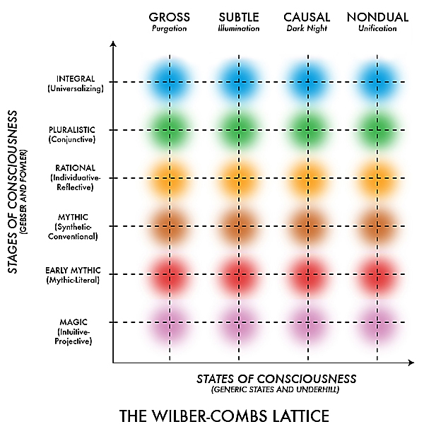
From: www.integrallife.com

More Specific Integral Exopolitical Applications:
Using Quadrants: Different influential exopolitical definitions or emphases (as those advanced by Dr. Webre, Dr. Salla and Dr. Hardcastle) seem to apply more specifically to the expressions of particular “quadrants” and their methods. Dr. Webre’s apparently focuses more on propitiating a “we” space in which intersubjective methods (like hermeneutics) and promoting a friendly communication environment can subjectively reveal what the cosmic community might be like. Dr. Salla’s apparently focuses more on the political processes or on the Interobjective, Systems Quadrant and Dr. Hardcastle’s focus on “consciousness” recognizes the crucial importance of the Subjective Quadrant on the one hand and of “Consciousness” as a universal (perhaps even Non-Dual) factor interconnecting everything behind the origin of all appearances, structures and forms. Like the quadratic expressions of any phenomenon, they are all simultaneously necessary and valid. Each discloses an aspect of the whole and together they reinforce the integral simultaneity of the three value spheres. If we naturally prefer one quadrant at the exclusion of others we may fall into quadratic reductionism or imperialism.

Using “Levels” Exopolitically: Since (according to Integral Theory), every disclosed object and interconnected item of knowledge is “situated” in a special relation to “altitude” (or general level of interpretive development) and to the quadratic zone/method used, being exposed to the same source of experience may be differently interpreted. If contact methods coincide and if contact experiences don’t differ too much different contactees would still interpret their experiences according to their predominant developmental levels. The other possibility would be that specific types of ETs approach humans that resonate more with them.

Please recall the colors assigned to different developmental “altitudes.” Some “amber-altitude contactees” (perhaps like Eduard “Billy” Meir and Claude Vorilhon/Rael, who present themselves as prophets and which have been considered as founding “UFO sects”) seem to predominantly demonstrate Sociocentric/Ethnocentric/Mythic disclosures and interpretations prone to mythologizing their experiences, to rigidly develop a sense of “mission” and to exclusively overestimate the cultural influence and importance of the particular civilization they may have contacted. They would also tend to generate authority-based or traditional-hierarchical support groups. In this situation contactee associations perhaps like “Unarius Academy of Science” in El Cajon, California or “Hermandad del Divino Cordero de Dios-Alfa y Omega” in Lima, Peru might also be the result of predominantly “Amber” interpretations.

Assuming that contacts with ETs did actually take place perhaps the extraterrestrial entities purposely chose these contactees due to an affinity and-or an interest to transmit particular information receptive to an “Amber” segment of the population in spite of the distortions that might also accompany it. Additionally, “Amber”- disclosed contactee information may be necessary to acquaint the world’s “Amber” populations (perhaps still a majority in the world) with the ET presence.

Predominantly “Orange/Rational” contactees may focus on objective, scientific and non-mythologized (or less mythologized) philosophical information such as engineer Enrique Castillo Rincón whose version of “Pleiadians” basically seems to be of quite normal -even if culturally and technologically advanced- well-intended people. Other possible contactees representing this modern-rational level of interpretation could have been technician Daniel Fry (contacting a human-looking nicknamed “Alan,” Bruno Sammaciccia (of the Amicizia mass contacts in Italy) and successful businessman and yachtsman Stefan Daenerde (contacting the philosophically inclined and apparently uncomplicated Iargans).

Regarding “Red altitude” contactees, I once researched a probable one that had some of these characteristics but who (after transformative contact experiences) became more religious and was evolving into an amber altitude. He was poor, streetwise, and impatient and - sometimes- even a feared character in his community. In spite of not inspiring credibility to the educated and academics (and perhaps because of it) he was frank, outspoken, down to earth, domineering, loyal with his friends. It seems that he had been given the opportunity to take extraordinary pictures and films of alleged ET craft in Puerto Rico and now aggressively embraced a unique role in the world trying to save it from disasters. Interestingly, he referred to a predominant segment of his ET contacts as the “Orion military arm of the 11:11 Confederation.” He told me that his previous values had changed and that his impatient, aggressive character had mellowed a little bit as he began to act with a sense of mission on behalf of the “Ashtar Command” (not on behalf of “Ashtar Sheran” whom he considered a powerful ET acting deceivingly on his own behalf, but on behalf of a large organization of powerful, high-level extraterrestrial entities called “ashtars”). I think that his self-enhancing, warrior-like “Red altitude” evolved toward a classic “Amber altitude” since during his contacts he was allegedly shown the importance Master Jesus had amidst confederations that defend our right to evolve without undue interference. He is now an evangelical minister.

As exopoliticians we would have to understand that researchers’ interests, their methods and interpretations would also reflect their overall “altitude.” For instance, many “Orange-rational” Ufologists (perhaps like Stanton Friedman) may predominantly focus on physical, objective “Ufological” evidence while “Green Altitude,” pluralistic, holistic exopolitical researchers (perhaps like Alfred L. Webre) would focus more either on facilitating the intersubjective or cultural “we” space of first-hand testimonies and also (to a lesser extent) on systems and political institutions. While the focus on systems is typical of a late-phase “Green altitude” transition into “Teal,” I think that Dr. Salla is already contributing to Exopolitics as an early-phase, integral, more inclusive-yet-orderly “Teal” because, while primarily focused on social and political systems, he also promotes interdisciplinarily the orderly use of every valid, quadratic research perspective and method (the soft and the hard sciences). I think that within this order are the seeds of further transdisciplinary discoveries.

We need a “beginner’s mind,” one curious and hungry to ever know more, opening up to views which always include wonder, intelligence and the Love binding creation. A word of caution: Let’s avoid level-based reductionism, exclusivism and imperialism.

As previously mentioned -in spite of a stage-based, evolutionary approach underlying Integral Theory- let’s be very careful not to hold our particular emerging cultural level of development in such high regard lest we disconnect from some important truths, specific facts and methods revealed and used in previous levels. “Levels” are considered to be stable structures but also are to be understood as general guidelines since consciousness itself may be able to surprise us fluidly cutting across levels. Let’s keep in mind that we may also misjudge individuals since there may be cases in which some lines of development related to values and self-identity may be highly developed while other lines of development (also related to values and self-identity) may be under developed.

Using “Lines” Exopolitically: Different individuals display different arrays of diverse, meaning-making and meaning-managing intelligent capacities. We should not think that the lines of all technologically advanced extraterrestrials are also highly developed and-or similarly developed. Perhaps the values, cognitive, needs, interpersonal, ethical, spiritual and emotional lines of ET beings can also vary considerably. Without a well-developed balance among all lines there could be serious limitations to what any being, however technologically advanced, might be able to achieve.

Conceivably extraterrestrials some may be trying to re-activate some of their atrophied lines through aggressive or non-aggressive forms of interaction with humans according to what each may be collectively allowed to do through shared intervention rules. While lines normally refer to subjective capacities, they also occur in all quadrants and the concept of “developmental time lines” perhaps associated with objective reality systems should be integrally addressed. Other lines to consider might be physiological development lines, species development lines and lines of cultural development.

A word of caution: Let’s avoid line-based reductionism, exclusivism and imperialism. If we are particularly good at something (like music, math, logic, ESP) and this discloses to us great depths of meaning from a particular line let’s not overvalue that capacity and dismiss integrally working on our other lines.

Using “States” Exopolitically: States are like momentary arrangements connected to perspectival experiences. They can also be understood as moments of interaction with experiential systems that become available through the connecting “all seeing eye” and capacity of consciousness. We can speak of states in every quadratic expression. For instance, if extraterrestrials come from a world which is not as “physically dense” as ours, states of intersubjective resonance (in comfort or discomfort) and understanding between Earth humans and varieties of aliens may be accompanied by temporarily structured energy states which allow for a temporary interaction. They might also be accompanied by especially adaptive brain states in the experiencer and by unique in-between dreamlike and objective-like subjective experiential states. Different provisional time frequency-energetic arrangements or interdimensionally converging states (ley line, gravitational or geomagnetic arrangements?) may facilitate physical and-or “interdimensional” interactions with extraterrestrial beings.

An exopolitician aiming at functioning in an integral level would be greatly assisted by habitually connecting with mind-expanding states of consciousness associated with feelings of empathy, compassion, respect, love, connectedness, non-attachment and greater perspective-taking. These positive, life-affirming, expansive states should not be confused with permanent evolutionary traits which show more in challenging real-life situations but they experiencing them consistently may assist development. Each person is unique in how this can be incorporated into their lives and contemplative prayer, communing with God’s creation in nature, Jewish mysticism, Muslim mysticism and Eastern meditative practices are a few options. However, we should be careful not to fall for the concept that if a state feels good it must be all we need to evolve. A word of caution: Let’s avoid state reductionism or imperialism.

Using Types Exopolitically: Types are already being incorporated in Ufology and Exopolitics. According to Integral Theory, they represent a recurrent, unavoidable, persistent element in everything. They persist across developmental stages. Types are unique characteristics that tend to remain stable for a long time even as other elements display changes and stage-like evolution takes place The idea of “types of extraterrestrials” needs to be carefully studied using the best evidence allowed by all quadrants without the prejudice that they must all be of the same nature and-or intentions either in a positive or negative way (falling into type-based reductionism or imperialism). In doing this we should distinguish between wide-ranging types and more specific types.

For instance, most people remain as men or women across their developmental stages. Scientists like Michio Kaku already talk about “types of civilizations” based on intensity of energy used (the Kardashev Scale). In Ufology and Exopolitics (in an include and transcend manner) we can still use the J. Allen Hynek “CE” classification scale of “close encounters” of the first, second, third kinds (types) to which, more recently, CE IV (physical and highly interactive encounter with ET beings) and CE V (or human initiated encounter) are being more recently added. “Types of contacts” should also be studied. Is it mental-telepathic, astral body, tensor beam, electronic, physical (within the contactee’s unaltered physical level, the ET physical level or an intermediate physical level), accidental, planned, natural, artificially induced. The “six subtypes” suggested by Ted Bloecher out of J. Allen Hynek’s CE-3 kind/type of contact also come to mind.⁶

Classification by types of physiognomy or by types of civilizations reported by experiencer-witnesses, credible whistleblowers and by probable classified documents which ended in the public domain has been attempted for instance by Manuel Lamiroy, author of the ever-evolving “EXOPAEDIA” that is found at http://www.exopaedia.org/.

The “paradigmatic perspectives” on the ETs considered by Dr. Michael E. Salla can be considered as an exopolitically useful typology: “intruders,” “helpers,” “manipulators,” and “observers” (or “watchers”). More information can be found at http://exopolitics.org/Study-Paper1.htm .

After reflecting upon it, “intruders” seem to be fixated or caught within characteristics of raiding, like “red” level individuals; “manipulators” seem to be fixated or caught within an ethnocentric, “Amber” phase; “watchers” seem to be fixated or caught within an “Orange” scientifically observing phase; “helpers” seem to be fixated with a “Green” altitude style. In this sense all of them seem to resemble a variety of Earth-human developmental stages or “altitudes” even if they all abide by shared rules of a holistic and integral level.

Is there a plan behind this? Do behavioral characteristics of different types of ETs have to coincide with that of individuals and cultures for there to be a worldwide, holistic interaction or are we anthropomorphizing about the ETs? Do they need to interact with us to free themselves from a fixation on specific levels of development that has been carried forward (as a shadow) into what corresponds to their integral stage? A word of caution: Avoid focusing too much on a type lest you become subjectively attached to a repressed “shadow” lingering across your evolutionary stages.

Perhaps we will eventually find that types of aliens can also categorized by how well they have integrated their lines of development, by their type of social structure (rigidly hierarchical or synergistic but freely associative?) and-or by what levels of reality (in what I call the “Tri-Realm Multiverse”) they have (naturally or technologically-induced) conscious, interactive access to.

Different Needs within Extraterrestrials
Now a little digression on the pattern we have been following until now. Why would different types of ETs show interest on us? If what is often heard about some aggressive, self-serving “reptilians” and some of the “greys” is true there may be a pathological relation between the collective “hive” mentality attributed to at least some of the greys and the excessively self-asserting mentality attributed to at least some of the reptilians. The same may be true between other ET species and, perhaps humans not possessing such clearly-defined tendencies.

We may be of interest to multiple ET species trying to sway us into “exploitative,” “complementary” or “interiors-combining” relationships. These three types of ET interests on us would relate to finding out how our consciousnesses may access (through three main types of logic or ways of creating meaning) the three correlated Physical, Subtle and Causal main realms of being and their interactions. In other words, different types of ETs would be after ways to enhance their own experiences by acquiring from us elements which they might lack and perhaps the less benevolent and physically-dependent ones would be interested in stimulating more physically exploitative, “either-or” logical ways; others in relational “both-and” co-definitions and the most advanced (up to a certain level of development both self-serving and in service to others) would be after mutually implicated, interior transformations associated with a deeper “neither-nor” (causal and multi-realm affecting) logic. They would be after creational capacities about which we may have a great potential.

The capacity of modifying sub-realms of existence as various combinations of the three main realms (representing an exteriors-dominant Physical Realm, co-equal interiors and exteriors in the Subtle Realm and interiors-dominant Causal Realm) may increase with greater levels of transdimensional knowledge, science and awareness and they would be after this. At a certain level of development we will have to confront the legal exopolitical issue of the rights which integrally sentient entities (like ourselves or others) have to maintain or modify how experiential realities are structured.

Now (in an even more speculative mode) we may have been – at least partially -genetically seeded by a various ET species and they (or their descendants) may now be eager to “harvest” some complex and creative human qualities in relation to their different specific needs. Some may want to improve themselves by learning from our “either-or” primal, physical survival impulses; others from our relational “both-and” potentials and still others from the way we may intimately reach (perhaps through prayer and selfless love) high levels of connection with the Universal Mind and Heart of the Kosmos active in the so-called “seed” or Causal Realm. Considering that physical universes in the Physical Realm may be subsets of the Subtle Realm, if ETs gain access to our Subtle Realm enactive capacities they may be able to generate more creative physical effects in various physical systems, timelines and universes. Considering that the Subtle Realm may be a subset of the Causal Realm, if they gain access to our Causal Realm enactive capacities they may be able to generate even more powerful effects both in the Subtle Realm and in the Physical Realm. The least advanced ET types may be after our Physical and Subtle Realm enactive potentials and the least physically dense and most advanced ones may be after our Causal Realm enactive potentials.

Since –due to our genetic combinations - we might possess greater capacities than the sum of many ET species combined (besides Earth’s hominids or proto humans which may have evolved naturally and under some ET intervention) many ET beings (from the original seeding evolutionary lines or even hybrid progenies) may understand that they have a “right” to intervene on us to try to heal/unravel different atrophies and blockages in their own different capacities or lines of development. If this is the case, a role for the Creator might be related with the patterns and principles that can be received by physical beings for instance through DNA and how it might connect, Causal, Subtle and Physical processes, forms and energies through the three logics and consciousness. Besides the laws of nature, God, transcending all three realms might have been the source for the essential process of designing humans. This will need to be further discussed.

As previously mentioned I think that different ET groups with different needs in all of this may have agreed to intervene under certain procedures if they don’t interfere with each other’s plans and abide by shared rules according to an integral level of understanding. I think that the more we become aware of who we are and how the Kosmos is structured, the more we will realize that we also have inalienable rights that have to be respected and the more ET species in general will have to negotiate with us in a respectful manner with us. Once we cease being possessed by aspects in our subconscious and unconscious with which ET entities may already be “negotiating” when they approach us in what we perceive as “on their own terms” they will start negotiating more with our conscious awareness levels “in our own terms.” The key would be to become more integrally conscious in every major aspect so as not to be treated as inferior creatures (as lacking a “conscious transdimensional status”) by some of the ET types. We need to become aware (that is, to make objective) what unconsciously possess our subjectivities. This is an integral-level awareness that will earn us the status of a sovereign species and force all ET types to negotiate with us on a conscious level.

We May Affect their Reality More
There’s an even more speculative idea I would like to mention. Are ETs weary of our innate creative capacities? Perhaps during human-ET interactions- our “altitudes,” enacting methods and worldviews may generate their own interactive-creative forms of actualization of what from our physical reality system are “potential” (rather than experientially “actual”) exterior-quadratic aspects in ET experiential environments. If some of the ETs normally operate in subtler, yet still, physical realities (less dense sub-realities of the Physical Realm) their physical exteriors may be more flexible and responsive to the property of “initia” (as opposed to inertia); more flexible under the creative, actualizing power of subjectivity.

When they interphase with our subjectivities having an actualizing/creational force adapted to denser, less responsive exteriors, we may be able to affect their more pliable exterior realities more than them at their own level. Inasmuch as our subjectivities are connected to their realities we may be able to affect them more intensely than how they are capable of doing it or subjectively influencing our own without technology! This may be one of the reasons why they may not be openly inviting into their environments and may be so until we reach minimum some integral levels of development or of kosmic awareness.

Conclusion
There are many ways in which the emerging integrative field of “Exopolitics” can adequately and synergistically combine and be enhanced by “Integral Theory.” Using the “Five Elements” of Integral Theory (Quadrants, Levels, Lines, States, Types) allows us to understand that different factors co-exist when studying any phenomenon and that they are useful across different disciplines. We can also begin to see that they derive from deeper organizing principles rendering not only an interdisciplinary approach but a transdisciplinary one possible. Integral Theory can allow us to think in more inclusive terms making Exopolitics more applicable to the multi-faceted reality of extraterrestrial contact. Crafting a more inclusive “Integral Exopolitics” would definitely enhance how researchers understand the extraterrestrial presence and would stimulate the creation of an integral awareness and culture more suitable to adequately interpret the premises under which extraterrestrial entities may be operating.

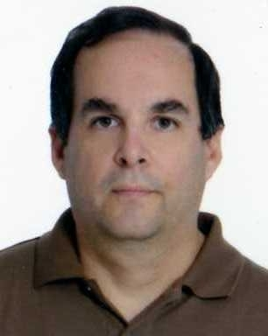
About the Author, Giorgio Piacenza
Giorgio Piacenza was born in Lima, Peru in 1961. At an early age he became interested in fundamental philosophical questions. Around the age of 12, he began to participate in Western, esoteric and Indian mystical groups and attempted to synthesize their knowledge. After a UFO experience at close range with other witnesses in 1975, he befriended contactees and began researching the UFO-ET phenomenon keeping in mind an interest for the cultural, political and scientific consequences which the presence of intelligent beings from other physical worlds and-or realms might have. In 1987 Giorgio earned a B.A. in Sociology from Georgetown University and received the Hoggson Award for Excellence in Sociology. In 1990, he earned two business certificates from John F. Kennedy University.
By 2000-2001, Giorgio became one of the civilian advisors to OIFAA, the Peruvian Air Force’s Office of Investigations of Anomalous Aerial Phenomena. Through the years, he has kept abreast of a wide-range of interests related to his inquiry on the nature of reality, interests such as the mind-body problem, shamanism, philosophy, cosmology and physics. He is particularly interested in philosophical, metaphysical and scientific integrative theoretical models including (since1981), of Ken Wilber’s evolving “Integral Theory.” In 2009, Giorgio was awarded a Certificate in Integral Theory by John F. Kennedy University and is currently contributing culturally transformative essays on Exopolitics, Philosophy and on the convergence of Science, Consciousness and Metaphysics. Giorgio’s Facebook page is: https://www.facebook.com/giorgio.piacenza.58
References
Assagioli, Roberto (2000). Psychosynthesis: A Collection of Basic Writings. Amherst: Synthesis Center.
Castro Sáez, Bernardo (2009). “Aportes de Niklas Luhman a la Teoría de la Complejidad” at http://polis.revues.org/2017
Esbjörn-Hargens, Sean (2009). “An Overview of Integral Ecology: A Comprehensive Approach to Today’s Complex Planetary Issues” at http://www.dialogue4health.org/pdfs/3_18_09/E_H_Z.pdf
Sean Esbjörn-Hargens “An Overview of Integral Theory” at http://integrallife.com/node/37539
Hochachka, Gail “Developing Sustainability, Developing the Self: An Integral Approach to International and Community Development” at http://www.drishti.ca/index.php?option=com_content&view=article&id=8&Itemid=4
Kaku, Michio “New World Transitions” at http://www.youtube.com/watch?v=1p5mZm6GVKM
Kegan, Robert (1994). In Over our Heads: The Mental Demands of Modern Life. Cambridge: Harvard University Press.
Kempton, Willett, Boster, James S. & Hartley, Jennifer A. (1996). Environmental Values in American Culture. Cambridge: MIT Press.
Maturana, Humberto & Varela, Francisco (1994). De Máquinas y Seres Vivos Autopoiesis: La Organización de lo Vivo. Buenos Aires: Editorial Universitaria.
Rentschler, Matt (2007). “Integral Glossary” at http://integralwithoutborders.org/resource/integral-input-21-papers
Salla, Michael E. (2004). Exopolitics: Political Implications of the Extraterrestrial Presence. Mesa: Dandelion Books.
Salla, Michael E. (2004). “A Report on the Motivations and Activities of Extraterrestrial Races – A Typology of the Most Significant Extraterrestrial Races Interacting with Humanity” at http://exopolitics.org/Report-ET-Motivations.htm
Salla, Michael E. “The Need for Exopolitics: Implications of Extraterrestrial Conspiracy Theories for Policy Makers & Global Peace” at http://exopolitics.org/Study-Paper1.htm
Sheehan, Daniel “Exopolitics and ET Disclosure Policy.” The 2007 X-Conference: UFOTV studios at https://www.youtube.com/watch?v=fPzqUORVLGE
Wilber, Ken (Boston) The Essential Ken Wilber: An Introductory Reader, Boston: Shambhala.
Wilber, Ken “The Kosmos Trilogy, part II. Excerpt B: The Many Ways we Touch” at http://integrallife.com/integral-post/many-ways-we-touch?page=0,2
Wilber, Ken “Excerpt D: The Look of a Feeling” at http://www.kenwilber.com/Writings/PDF/excerptD_KOSMOS_2004.pdf
Wilber, Ken (2006). Integral Spirituality Boston: Integral Books.

ENDNOTES
1 His overview can be found at http://www.dialogue4health.org/pdfs/3_18_09/E_H_Z.pdf
2 See Wilber, Ken “Excerpt D: The Look of a Feeling” at http://www.kenwilber.com/Writings/PDF/excerptD_KOSMOS_2004.pdf
3This can be read in Manuel Lamiroy’s account at http://www.exopoliticssouthafrica.org/exopolitics.htm
4 One of my explorations on this subject, attempting to stimulate a revision and enhancement of “AQAL” is found at http://peruexopolitics.blogspot.com/2013_07_01_archive.html
5 Please see: http://www.youtube.com/watch?v=mW4LTqRJDW8.
6 Go to http://en.wikipedia.org/wiki/Close_encounter


:


